Image localization in satellite imagery with feature-based indexing

Introduction

This work will demonstrate how we can search a map database for possible regions that match query images we are interested in. We use image features as visual words to index and search for the locations in map databases. The geographical dimension of the features and the scalable indexing system lead to our efficient image search system. For detailed information of how the system works please read our paper in the paper folder.

Demo Video
demo.avi is screen capture video showing the process that we run map search tasks in the system. Please go download ffdshow if the video doesn’t play on your computer for missing codec.

Live Demo
To install the live demo, run demo.exe to unzip the demo package to your hard drive.

To run the live demo, please execute demo/register.exe and click menu item Geo*->Load Predefined Data. The demo program will then start loading a search project defined by mapsearch.ini. It reads all the feature files in the database, constructs the indexing of the map database, and loads the query images. The entire process will take about 5+ minutes depending on the hardware of your computer.

After loading the data, an image list window will show all the thumbnails of the query images. User can double click the thumbnails to search the selected images in the database. For more functions of the demo, please read the following instructions.

Instructions

1. Interface

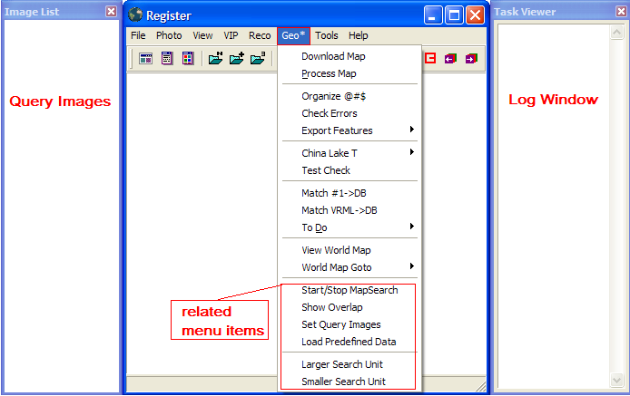

2. Menu Items
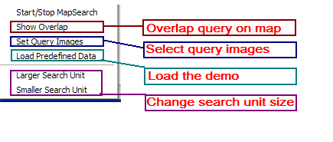

3. Toolbar Buttons

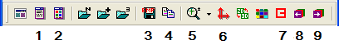

Functions:

- , show/hide log window
- , show/hide query image window
- , save current view as an BMP file
- , copy current view to memory
- , zoom current view of main window
- , reset the coordinate of main window to original
- , show/hide features on map / query
- , show previous/next possible location.

4. Query Image List Window

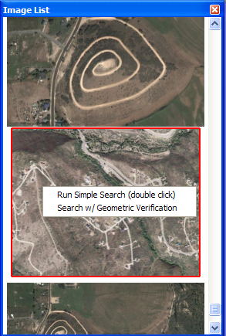
Functions:

1. Drag pictures/folder to the window to add images to the list

2. Single Click to show a query image in main window

2. Double Click on an image to run query

3. Shift + Double Click to run query with geometric verification

3. Right Click on an image to show the query menu

5. Main View Window

Click + Drag to pan the view,
Ctrl + Click + Drag to rotate the view,
Shift + Click + Drag or use mouse wheel to zoom the view,

