GEO* progress report: 29 Feb 08
Jack Snoeyink, Leonard McMillan,
Wei Wang, Marc Pollefeys (UNC Chapel Hill)
Charles Chui, Wenjie He (U Missouri, St Louis)

The research objectives of this proposal are threefold. First, we will complete the theory of bivariate meshless wavelets. Second, we will develop point/knot selection algorithms which are optimized for specific geometric tasks and data queries. And third we will realize a practical implementation that demonstrates the advantages of our modeling approach. UNC-UMSL Geo* proposal, June 2004

Summary
In this document, we report on the recent progress in the three areas from the proposal: the mathematics of meshless wavelets, selection of points for irregular terrain representation, and the practical implementation. In brief, (1) in the mathematics, our project had already made two significant advances in two approaches toward meshless wavelets, both of which still fall short of the original, ambitious goal; our recent progress is in engineering the implementation to be sufficiently fast that we can already use what we have, and can explore the properties in practical situations using the mathematics we have, and learn from this practical exploration properties that may allow the breakthrough that is still needed. (2) In the selection of points for irregular representation, we demonstrate significant compression using the prototype tools that we have so far, especially for data that is “clean.” In the next two months, we will complete a refactoring of these tools into a general framework that will allow a user to put together an efficient pipeline to clean and process data from sensors with varying characteristics. (3) Our practical implementation using streaming has always been a strength, by allowing us to demonstrate results on realistic data sizes. To this we have added GPU-based feature identification to connect with images. We close with specific milestones from the proposal. Accompanying this is a number of auxiliary documents, cited below, which give details on each of the areas of research in this report.
Data sets
To establish context, I want to begin by mentioning the characteristics of a couple of the data sets that we use for demonstrations; we thank the sources for these, as well.
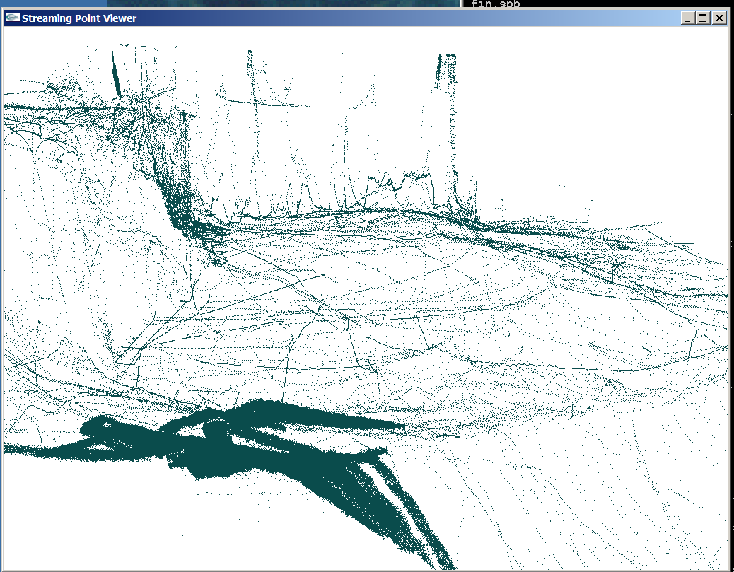
Bathymetric data, Rob Anderson (NGA): sonar returns from a variety of sensors having different densities and error characteristics: roughly 90% from one very accurate and dense sensor (not pictured, but it would occupy the front 1/3 of the following image), 9% from one multisensory boom giving data along an overlapping path (seen dark) with seemingly stochastic position errors, 0.5% from a ship that tracked all over, and the remaining 0.5% from nearly 30 sensors, some giving isolated tracks, and some having obvious mis-registration errors.
SRTM gridded Lidar, Jim Little (NGA): An area near the University of Utah, chosen for its mix of bare earth, tree-covered, and urban terrain, and for the availability of THED (Terrain Height Error Data). This is a digital surface model, rather than a digital terrain model, and it contains some systematic errors that seem to be caused by slight inconsistencies between the data gathered on different radar passes. We have also used raw Lidar in previous reports (including the 4 billion returns from Puget Sound Lidar Consortium) but we will stick with this smaller example here.
By the way, we believe it is important to work on algorithms that scale to the data set sizes that occur in practice, and our streaming formats make that possible on commodity processors.
Meshless Wavelets: Mathematics
The holy grail would be to develop a wavelet representation for irregular data: We need local support, a tight frame with a large number of vanishing moments would be able to reproduce polynomials of high degree, thereby showing the expressiveness of the representation and giving good guarantees on the accuracy of approximation.
We have explored three approaches (by Liu, Chui, & Basu) toward Meshless Wavelets, which we briefly summarize in the following paragraphs and pictures, and described in more detail in the accompanying documents. The first two are significant, novel contributions. Although none of the three attain the holy grail of a wavelet in the strict sense – in which a finer basis can reproduce a coarser basis exactly using its finer elements – we are able to incorporate the properties that they do have to implement improved compression for irregular data.
Bivariate B-splines from centroid triangulations (Liu)
We began the project hoping to build wavelets out of Neamtu’s definition of simplex splines from higher-order Delaunay triangulation, but found out that the Delaunay was too restrictive. This lead PhD candidate Yuanxin Liu to extend Neamtu’s work to arbitrary triangulations, using a scheme we call “centroid triangulation” to generate the equivalent of higher order triangulations. This scheme is a natural bivariate extension of the univariate B-spline, a long-sought goal. It is described in chapters 6-8 of Liu’s forthcoming PhD thesis, included in draft form.
Liu points out that, “although terrain modeling could benefit from the ability of triangulation to handle large and irregular data, it often resorts to other tools that provide a better variety of functions, at the expense of handling irregularity or speed. In particular, if speed is more critical than handling irregularity, then it borrows from the large number of tools available for image processing, which require that the data lie on a grid; if handling irregularity is more important than speed, then it uses various radial basis functions, which are slow for large data sets because they are globally defined.“ It is this insight that we take from this work. For example, in many cases we compress terrain by either implicitly or explicitly making some smoothness assumptions; one of the general benefits of the work on building spline bases on top of arbitrary triangulations is that we can use data-dependent triangulation to preserve slope discontinuities in terrain, as shown at right. This extends to Chui’s method as well.
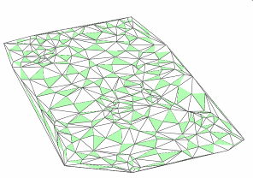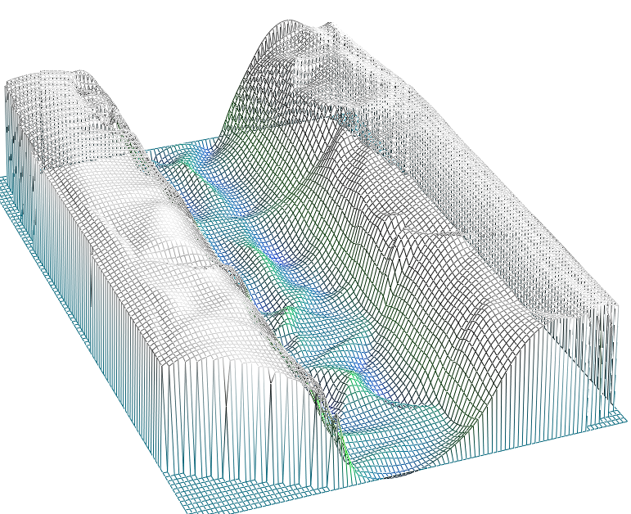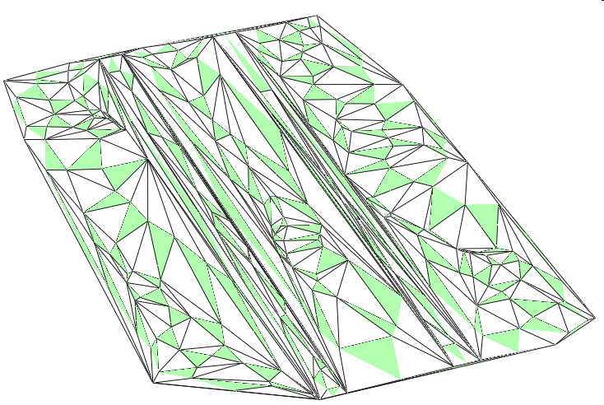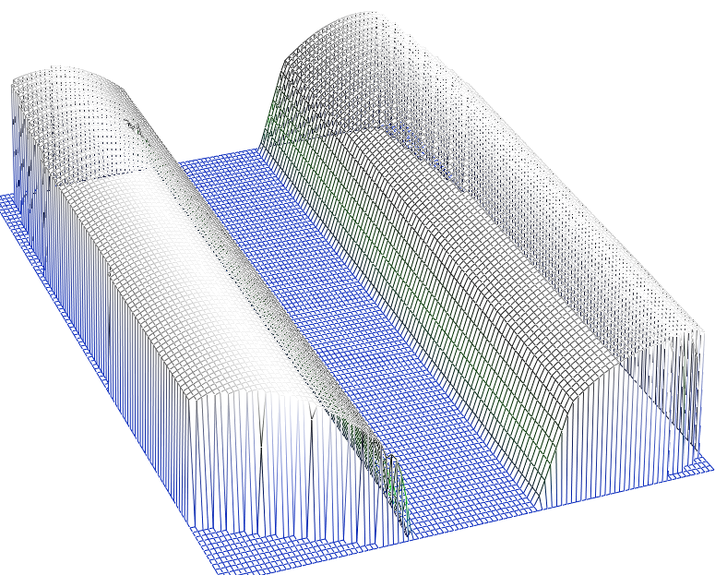

One-ring interpolatory subdivision surfaces (Chui)
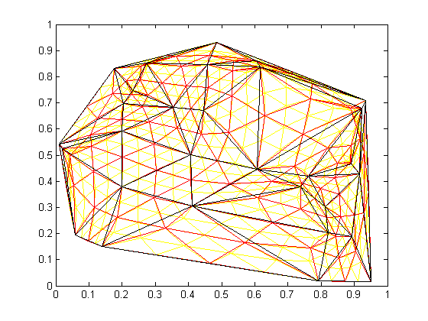
The subdivision surface is the limit of the refinement and averaging procedure; the figure below shows three levels of refinement. To analyze surface properties, and how they depend on the parameters chosen, mathematicians developing wavelets and splines capture the refinement and averaging by a single recurrence formula: 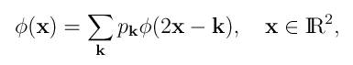with the following interpretation: By simplifying the geometry to a lattice, which effectively captures behavior at regular points, we can write the refinement as just a scaling of the lattice (2x) and invariance under translation to lattice points (-k). The averaging is captured by weights (p_k) that sum to unity and are non-zero at the few neighboring lattice points that contribute to the averaging scheme. By studying the functions phi that satisfy this formula, we can learn constraints on the weights p_k and the refinements (which can be other than just scaling by 2) that lead to subdivision surfaces with good properties. E.g., the weights should sum to unity so that constant polynomials can be reproduced from samples. Note that extraordinary points need to be handled as special cases.
The main freedom in the recurrence formula is the choice of averaging parameters. If we want to preserve the original data (interpolatory subdivision), then previously the only way to get more freedom is to take more lattice points -- larger stencils, with more special cases due to possible arrangements of extraordinary points. CK Chui proposed to give more control with smaller stencils by generalizing the formula to matrix weights
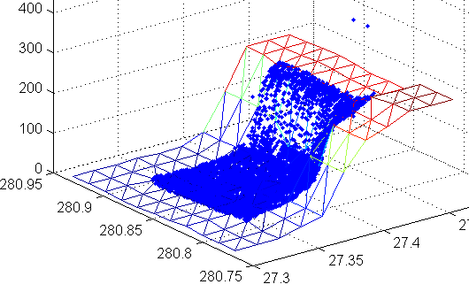
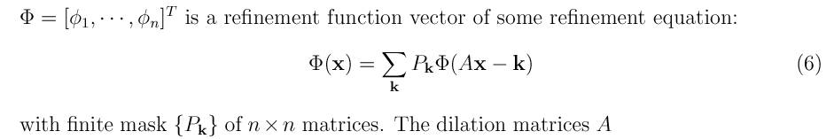
The idea is that along with the xyz coordinates of the vertices can be some additional (hidden) coordinates that control smoothness, etc. These coordinate values are mixed in with the Cartesian coordinates by the matrix weights, but are otherwise ignored when calculating the surface. For detail, see the accompanying papers.
Our initial implementation of this scheme to explore how the hidden information could be used to preserve both elevation and slope was discouragingly slow. Recently, however, we have been able to refactor the code and reduce a running time of 330 seconds to less than 8 in MATLAB, allowing us to compute the best subdivision parameters for examples such as that at right using bathymetric data. From these examples we are learning to choose parameters based on surface shape characteristics; once the parameters are chosen and compressed, we can decompress and evaluate subdivision surfaces with speeds comparable to our implementation of ESRI’s quintic surfaces, albeit still slower than our implementation of quadratic interpolants.
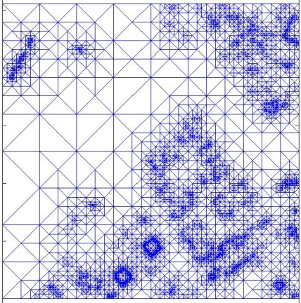
Right-triangle TIN (Basu)
Chiu’s, and to some extent Liu’s, schemes support a version of meshless wavelets if we do not give complete freedom for where to place the points in refinement. Partly for comparison, Suddha Basu, who earned his MSc and moved to Yahoo, implemented a restricted form of hierarchical triangulation known as an RTIN, or right-triangulated TIN; and example is shown at right. Because of our preference for truly irregular triangulations, we use this primarily for comparison, but it may play a more prominent role in our final wavelet analysis.
Fitting a representation to data
There are two tasks in fitting a representation of a surface to data: breaking the surface into patches that will be represented by some basis function or functions (linear, quadratic, subdivision, B-spline) and determining the parameters for the basis functions. Determining the basis functions is harder; parameters can often be fit by local least squares. For our representations, choosing the basis involves selecting knots or key points.
Selecting knots and key points for compression
In general, the task of selecting key points for generating compressed, irregular representations can be tackled by refinement, starting with a coarse representation, or by decimation, starting with a fine representation. We have implemented both approaches: Our decimation approach uses streaming, so is effective even for large data sets, whereas our refinement works best when starting with a small sample of reliable data.
Both schemes work well with “clean” data, but tend to preserve outliers if they are present. A digital surface model will have far more outliers than a digital terrain model. Outliers are especially bad for compression schemes because it is hard to predict the bits from the neighboring points, so many bits need to be written. On the other hand, some outliers are essential breaklines (for example, building edges if you indeed do want a digital surface model).
Our plan in this phase has been to combine local patch fitting to classify points. We have implemented some streaming modules that do this using one-rings and two-rings in an irregular triangulation as the neighborhood for which a patch can be fit. We are turning this into a general mechanism for classifying and filtering irregular point sets that allows a user to select a neighborhood, a patch type, and a filter or classifier, so that classified points can be streamed into the simplification tools, allowing it to make better choices to preserve essential and representative points for compression. The planning document “TMV tools” outlines the modules that we have and those that remain to be implemented over the months of March, April, and May, so that this toolkit can be delivered.
Compression Results
The bathymetric data is so unevenly sampled that it is difficult to compare with an image-based compression scheme like JPEG2000. The bathymetric data in our single UTM zone 18R would require a 130,00x120,000 grid to get 10cm post spacing, or 31GB for 16 bit raw data. JPEG2000 would compress this by a factor of 100-1000; we’ll be optimistic and say the data is 31MB, compressed. Storing the raw points in 55x4 format takes 150MB.
Storing a triangulation in binary format takes 330MB, but in compressed format takes 9.84MB, which is already better than JPEG by a factor of at least 3. Filtering and simplifying to 10% gives us 1.34MB, or 4.3% of the JPEG size, and to 1% gives 160KB, or 0.52% of the JPEG size.
The Utah data is less advantageous. We start with a small 1825x1380 raster, which would be 5MB at 16 bits. JPEG2000 should compress by a factor of 100. Storing the full triangulation in compressed format takes us 3.5MB, and simplifying to 10% gives 455K, or 9% of the original, and to 1% gives 57KB, or 1.15% of the original, not quite breaking even with JPEG2000. The digital terrain model (instead of the digital surface model) compresses more effectively; we will have to send the auxiliary details shortly, along with error parameters, due to problems with getting error values from both HRTI and our tool.

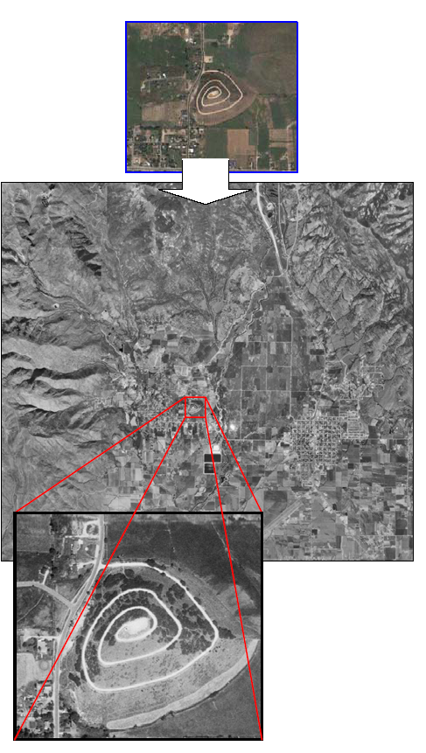
Feature-based image matching
PhD candidate ChangChang Wu has implemented SIFT (Lowe’s Scale Invariant Feature Transform) on GPUs (Graphics Processing Units) for speed. SIFT does irradiance-based keypoint detection and generates geometric descriptors for feature location and matching. (The implementation is available here: http://cs.unc.edu/~ccwu/siftgpu/)
In this project we have extended this to a method to index ortho-map databases with image-based features and search a map database for regions that match query images of unknown scales and rotations. The method extends the “visual word” approach for image matching with geographical dimensions, and uses the extended visual words to index a 2D location grid of map. The image matching runs at 2Hz on a 3Ghz PC. Geometric verification, which determines the most likely locations, plus the scaling and rotation transformation, does not run on the GPU, so it takes about 1 to 4 seconds to verify the top 10 putative locations, depending on the number of features. For details, see ChangChang’s accepted submission to ISPRS’08, which is currently under revision for inclusion in the proceedings.

Shortest paths computations
Vishal Verma, a new PhD candidate, has taken over the shortest paths computation. We had previously evaluated several algorithms (including Dijkstra’s and Level Set methods) on small examples. Vishal is exploring how to scale up the Continuous Dijkstra algorithm – shortest path algorithms depend on the entire input terrain, so they are not a good candidate for streaming in data in arbitrary order. The fact that our streaming has a coarse underlying grid suggests efficient ways to re-order the data so that we can process it in a streaming order, keeping only an interface in memory. Fast marching methods apply a similar idea in fine grids; Vishal’s work looks to be the first to extend this to irregular data. This will complete over the summer.
Evaluation of HRTI Analysis Tool
Because error statistics frequently do not capture the patterns of systematic or correlated errors, we have always used an error visualization tool. The one that we developed for our use, based on the research of collaborator Chris Healey, ca effectively show two or more errors simultaneously: http://www.csc.ncsu.edu/faculty/healey/download/3dpvt_poster.06.pdf
We have also evaluated the HRTI Analysis tool and suggested refinements, including the proper handling of NODATA values in histograms, and support for irregular representations such as TINs. Our evaluation was sent to John Marshall, Mary Perkins, Craig Rodarmel, Kurt Rogers, and Todd Johanesen in October 07; I have included it with the auxiliary documents.
Status of milestones from the proposal
In the proposal, we said, “In phase 2 we will focus on developing application specific algorithms for selecting hierarchical point sets. The outcome of this phase will be various demonstration systems and various software and mathematical analysis tools. The specific milestones of this phase include:”
1. A general optimization framework for selecting point sets
2. A focused effort of selecting point sets for compression
Status: MATLAB prototype complete for both, streaming prototype giving results for filtering, simplification, and compression. We are generalizing both the filtering and simplification mechanisms based on what we have learned, with the new prototypes available in April (filtering) and May (simplification).
3. Selection of critical points for image registration tasks
4. The development of indexing schemes and searching strategies for database query and retrieval
Status: GPU-SIFT does 3, and the index does 4.
5. Selection of critical points optimized for reconstructing iso-height contours
Status: awaiting general filtering mechanism, and will probably continue waiting as we invest the efforts into the higher priority milestone that was mentioned for a possible phase 3: Path-planning tools with adaptive refinements.

