Terrain Compression:
Notes on beating JPEG2000 2 Apr 08
Jack Snoeyink (UNC Chapel Hill),
in collaboration with, Leonard McMillan,
Wei Wang, Marc Pollefeys (UNC Chapel Hill)
Charles Chui, Wenjie He (U Missouri, St Louis)

Summary
We beat JPEG 2000 for terrain compression for applications where the resolution of the data, the scale of the phenomena, or the level of interest is not uniform over the terrain. Our main difficulty is not to support this claim, but rather to argue that these are (or are becoming) important at a time when NGA has sees every map as a raster, which by definition has uniform resolution across a map. We therefore describe some of the issues that we have with data from NGA before we give specific details on comparing our compression to JPEG2000.
Our conclusion is that we break even or are a little worse than JPEG 2000 on our worst-case scenario: raster digital surface models in areas with many buildings or trees introducing difficult-to-predict discontinuities, but better by 10-50 fold when data is non-uniform. Moreover, we do this in a context in which the processing scales to realistic data set sizes by decompressing and compressing seamlessly and on-the-fly.

Introduction
In our NGA/Darpa project, “Meshless Wavelets,” we are building representations for terrain from irregular data that are supposed to beat JPEG 2000, a wavelet compression method for images that is frequently applied to compress terrain. JPEG 2000 is a very good general image compression scheme, and while it is not hard to improve it or raster terrain by 10-50%, it is very ambitious to try to beat it by a factor of 100 in general. But we are not trying to beat it in general, but in a way that can be tuned for specific applications, by using scattered data that is collected from LIDAR, from multiple scans, or multiple IFSAR passes, or that is then filtered to be just the bare-earth points that would constitute a digital terrain model (rather than all returns that would constitute a digital surface model) or that would focus on the roads, paths, ridges, or valley bottoms that affect mobility, visibility, or drainage, while representing the less “mission critical” portions of the terrain at coarser resolution.
In this document, I want to present the evidence that we match or are a little worse than JPEG2000 on our worst scenario, and that we are better on other scenarios. I will organize this around data sets that provide these scenarios.
Worst-case: SRTM data from University of Utah area
From SRTM radar data obtained from Jim Little (NGA), we selected an area near the University of Utah, chosen for its mix of bare earth, tree-covered, and urban terrain, and for the availability of THED (Terrain Height Error Data). We call this our worst-case scenario for several reasons:
- The data is gridded, and therefore we have uniform resolution throughout. Image-based representations need store only the elevation and not the xy coordinates. Moreover, the data is floating point, and we have only an int16 JPEG2000 compressor, so we must first truncate, reducing the entropy and making job of JPEG2000 easier.
- The urban portion (70% of the surface) has many discontinuities that will be better captured by a compression scheme tuned to images than one that aims to model terrain.
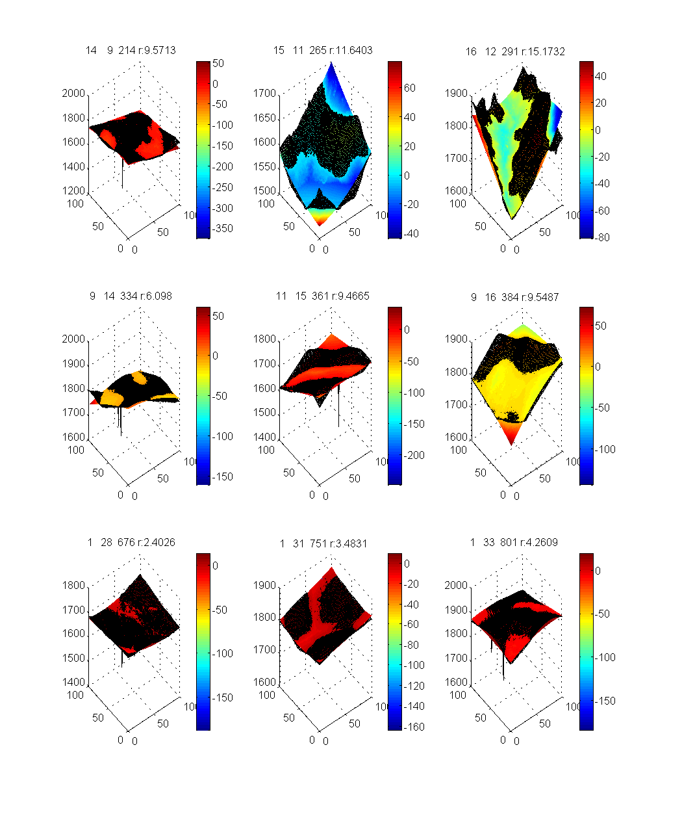
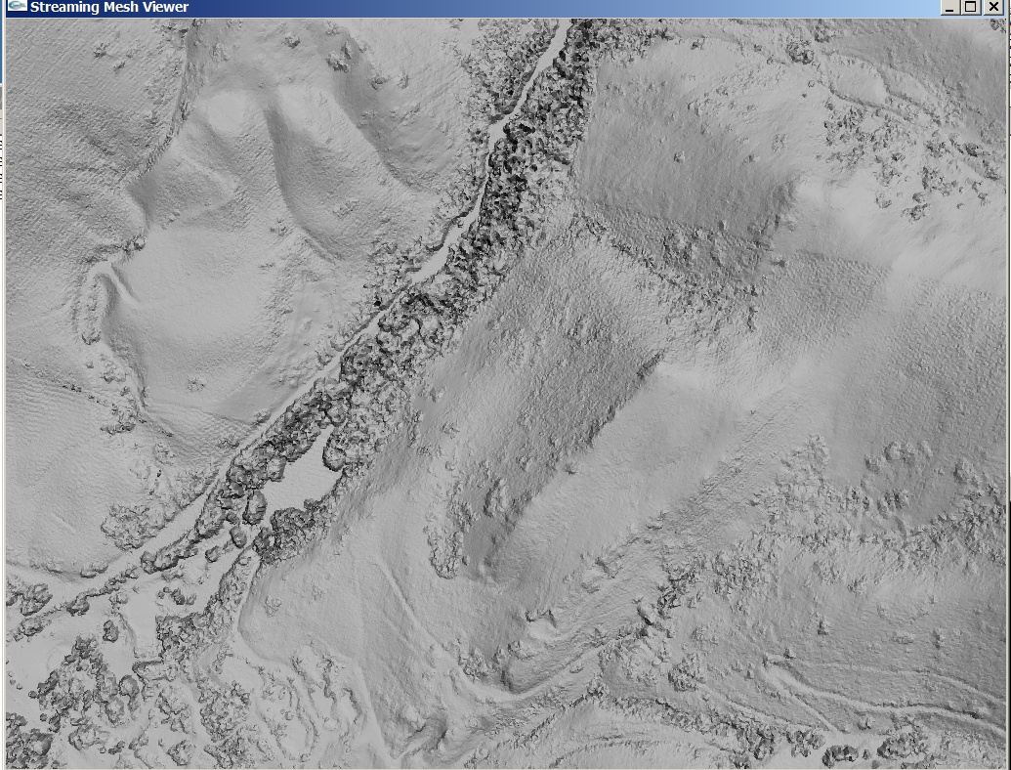
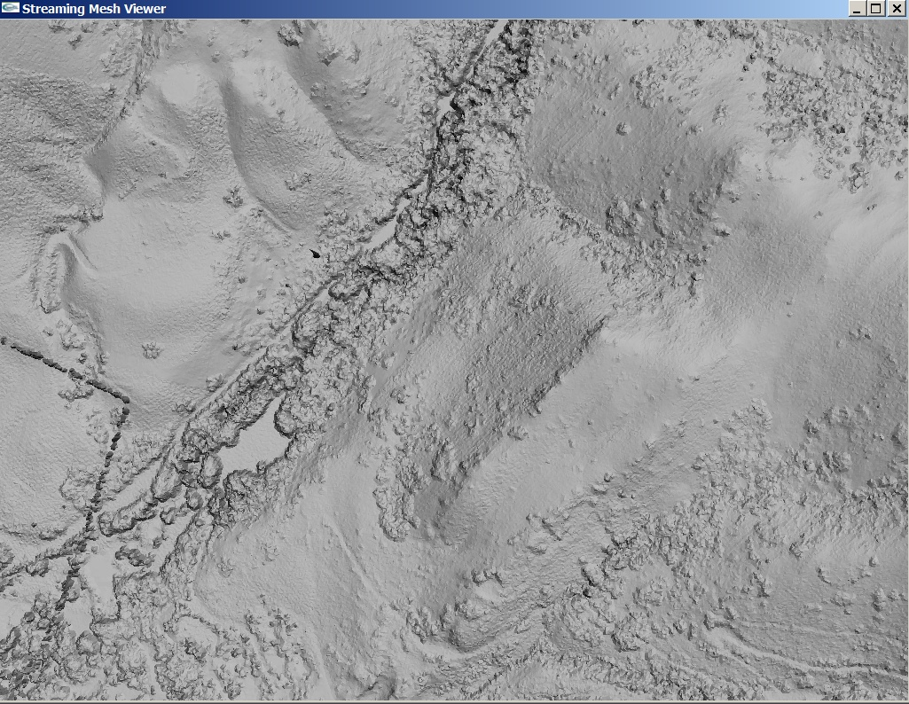
- This data also contains:
  - large outliers due to misregistered phases in IFSAR or radar reflections among buildings (spikes below patches at right),
  - non-terrain elements, including not only buildings and trees but even power lines (filtered in the second image below), and
  - systematic errors such as washboarding apparent at right, probably due to the radar shadow of hills.
We filter the worst of these, but then the error measuring tools (like the HRTI Analysis Tool) penalize the resulting surface for differing from the raster elevations (especially using the metric of RMSD) and slopes.
We did the following experiments:
- Taking an 1380h x 1825w Raster DEM with 32bit float values at 1m post spacing, we truncated to 16 bit integers to run JPEG2000 compression and determine the compression percentage (2.29%) and compression ratio (43.66). Average absolute error and RMS error were good (< 0.5) once we compensated for its bias to round up by rounding down to convert to integer.
- Returning to the original float32 data, we did a coarse filtering that simply removed isolated spikes, and then reduced the mesh size to 10% and 1% using our simplification tools based on the quadric error metric, obtaining compression that is 3.54 times worse and 2.32 times better than JPEG2000, respectively. Average absolute and RMS errors are correspondingly better with lower compression and worse with higher compression; the tradeoff that we would expect.
- With slightly more aggressive filtering of outliers, compression improves to 1.9 times worse (for 10%) and 4.16 times better (for 1%) than JPEG2000. We believe that filtering makes a better digital terrain model (e.g., the powerline and some trees are removed), even though the error of comparing to the original raster necessarily increases. RMS error (0.756 & 1.052) especially increases because RMS squares the outlier distances.
Original Info:  1380h x1825w Raster DEM |  |  |  |  | Filter extreme outliers only |  | More aggressive filtering
 |  | Original | Int | JPEG2000 | Q2R Var |  | L1min
File Size |  | 10,469,930 | 5,243,434 | 239,810 | 849,249 | 103,303 | 455,287 | 57,707
Compr.% |  |  | 50.08% | 2.29% | 8.11% | 0.99% | 4.35% | 0.55%
Ratios |  |  | 2.00 | 43.66 | 12.33 | 101.35 | 23.00 | 181.43
Filter |  | N/A | N/A | N/A | Q2R | Q2R | L1R Min | L1R Min
Compr. |  | N/A |  | JPEG2000 | 10% | 1% | 10% | 1%
File |  | GeoTiff | GeoTiff | JPEG2000 | SMC | SMC | SMC | SMC
Type |  | Float32 | In16 | Int16 | Float32 | Float32 | Float32 | Float32
Interp. |  | N/A | N/A | N/A | Linear | Linear | Linear | Linear
# Verts |  | 2,518,500 | 2,518,500 | 2,518,500
# Tris |  | 5,030,592 | 5,030,592 | 5,030,592
Z-Elev. | Min | 1,440.51 | 1,440.00 | 1,441.00 | 1,472.12 | 1,472.70 | 1,440.51 | 1,440.51
 | Max | 1,957.25 | 1,957.00 | 1,958.00 | 1,956.69 | 1,956.31 | 1,956.84 | 1,956.56
 | Avg | 1,616.61 | 1,616.11 | 1,616.59 | 1,616.55 | 1,616.38 | 1,616.30 | 1,615.98
Elev. | Min | 0.000 | -0.999 | -2.714 | -65.089 | -67.598 | -65.803 | -67.478
Error | Max | 0.000 | 0.000 | 2.000 | 86.260 | 86.104 | 3.689 | 14.373
 | Avg | 0.000 | -0.500 | -0.024 | 0.001 | 0.020 | -0.257 | -0.202
 | Avg|| | 0.000 | 0.500 | 0.365 | 0.213 | 0.534 | 0.348 | 0.626
 | RMS | 0.000 | 0.578 | 0.452 | 0.367 | 0.863 | 0.756 | 1.052
Slope | Min | 0.000 | 0.000 | 0.000 | 0.000 | 0.000 | 0.000 | 0.000
Error | Max | 0.000 | 43.801 | 84.346 | 120.201 | 140.616 | 135.857 | 149.656
 | Avg | 0.000 | 8.940 | 13.494 | 8.214 | 13.296 | 10.495 | 13.733
 | Avg|| | 0.000 | 8.940 | 13.494 | 8.214 | 13.296 | 10.495 | 13.733
 | RMS | 0.000 | 10.279 | 15.660 | 10.641 | 18.467 | 14.836 | 19.264

Other things to note: The rows to pay most attention to are shaded: the compression percentage and ratio, and the average absolute error and RMS (root mean squared) error.
We had to round down in converting to integer, introducing a bias in the average error, because our jpeg2000 seemed to introduce a corresponding bias in the other direction.
The improvement is in compression with more aggressive filtering to be expected; outliers take more bits because they are not predictable.
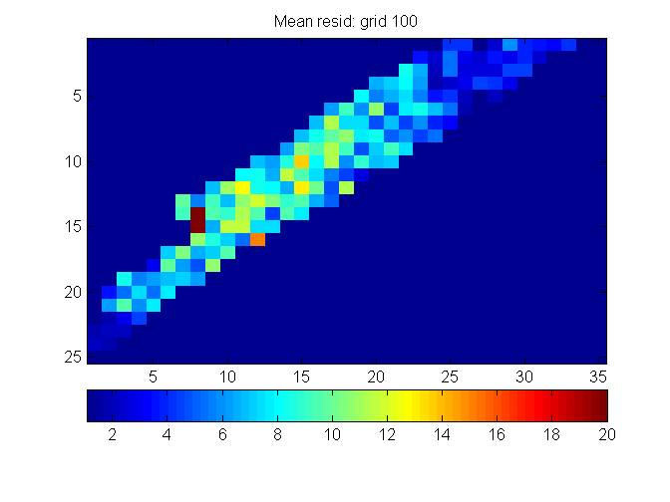
A notable feature of our approach of using irregular data structures is that decisions on filtering remain tied to the original data – we implicitly have an audit trail for the decisions to consider a set of data as an outlier, and tools could be implemented to make this explicit in applications in which this critical inspection is desired.
Intermediate case: SRTM data “canyon” from University of Utah area
For a data set that has a particular area of interest, we also considered dem_3m_a1_slc_canyon.tif that was on the disk from Jim Little. This is a 2.5Kx3.6K raster that captures data from one particular canyon near the University of Utah area. Unfortunately, with its size, we are not able to run it through our JPEG2000 compression tool as a whole. Compressing pieces will give similar results to the above.
We are using this data set, however, to study the terrain types that we would like to capture with our meshless wavelets, and to look at filtering. Ideally, these two are closely related: if we can make the detail coefficients for our wavelet representation correspond to details like trees and buildings, then we will actually improve digital terrain models by suppressing detail coefficients, while compressing them at the same time.
Using our MATLAB code for best fit polynomial and subdivision surfaces, we are characterizing smaller areas (100m² to 10,000m²) to determine the number of surface patches needed to represent them, and to improve the filtering of non-terrain data points. It is through filtering that we obtain irregular data sets from rasters, which nevertheless are more predictable than the original.
As a back of the envelope calculation, suppose we want 100x better than jpeg2000, which we assume is 50x better than the raw input, we would then want to represent each batch of 5,000 data values with 32 bits. We want to determine whether this is feasible, so, for now, we will consider how well our subdivision and spline surfaces can fit to smaller sets of data.
The easiest sets to work with an a prototype on rasters are square tiles, so, even though we pride ourselves on working with irregular data efficiently, for this experiment, we break this raster into 900 tiles of 100m x 100m, of which 180 (20%) do not have zero values. Of these, 11 of the tiles contained large outliers and are omitted from the analysis, leaving 169 tiles. We fit subdivision and spline surface patches to the data in each tile and characterize the patches by residuals and surface geometries.
To discuss the results, I’ll present some “small multiples” – images containing many small graphs for patches that have similar geometric characteristics. The purpose of these experiments is to determine how many tiles are able to be represented well by a single patch, which gives an indication of whether our subdivision or spline patches are sufficiently expressive at this level of resolution, or whether we need to refine to a higher resolution. Some points that are not well fit, are actually outliers or non-terrain features, as we will observe below. Note further that the use of tiles can be just a proxy for more data-sensitive ways of partitioning that we do in production code.
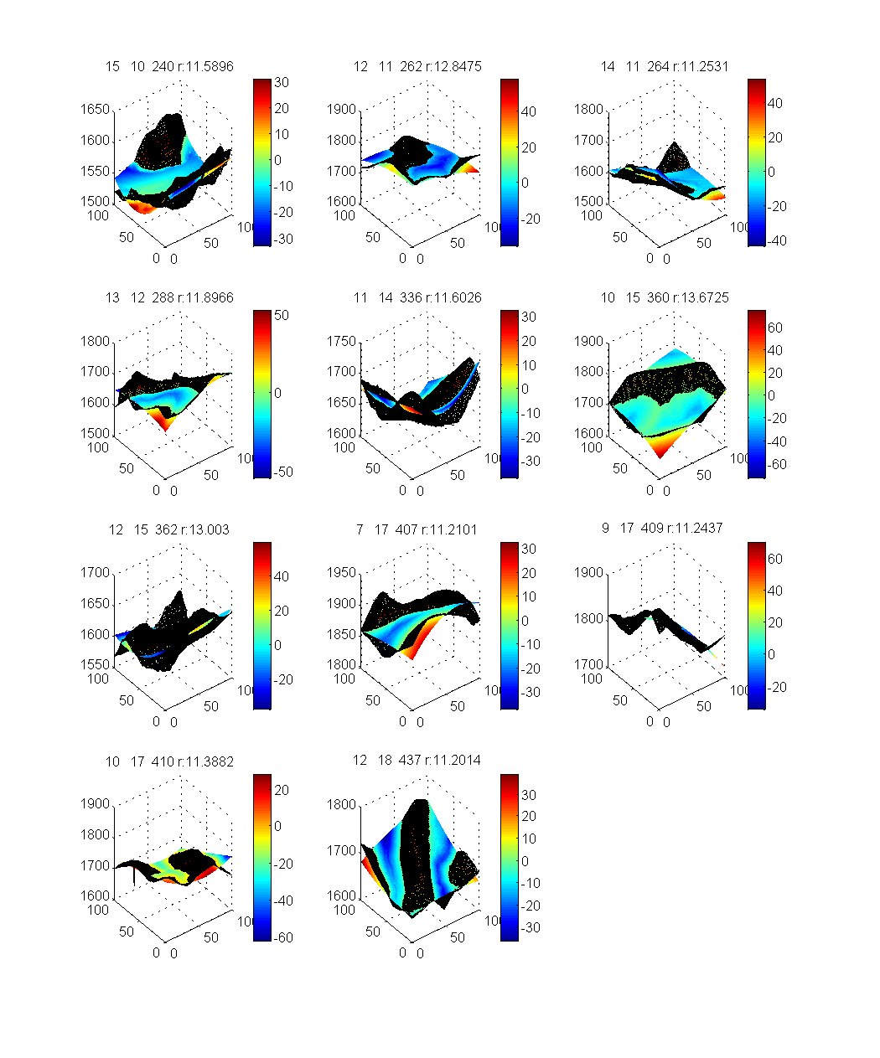
Here are some example outcomes and conclusions: The points from a tile are plotted in black, and the patch is colored by the residual error according to the color bar with each plot.
At right, we see the 11 patches (6.5%) in which the average residual errors are greater than 10m. These are poorly represented by a single patch at this level of detail because the terrain has important features at finer resolution than a tile. For these tiles, we would need to subdivide and use smaller patches to capture their data accurately.
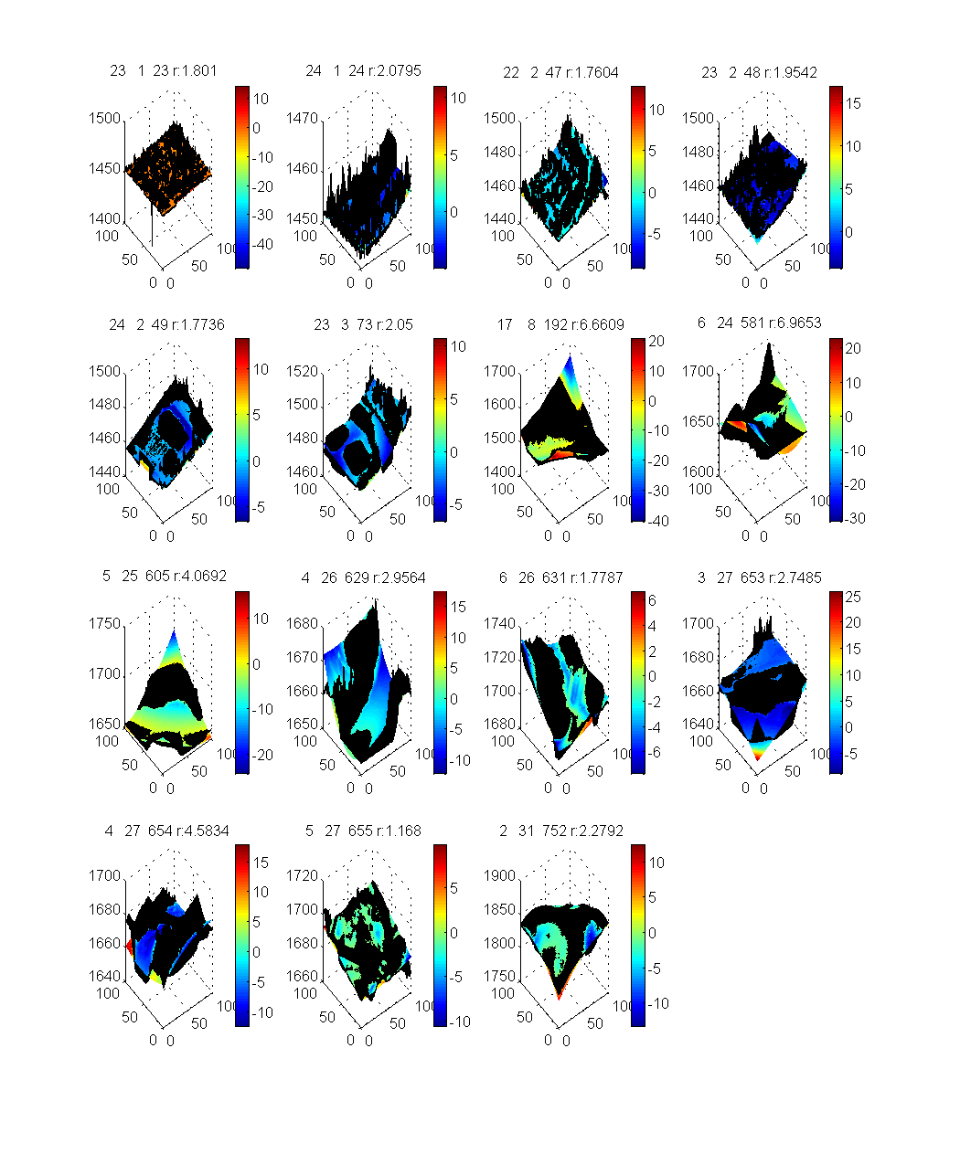
Below we see 15 tiles (10%) that are fit by relatively flat patches. They have a few large residuals, but are otherwise well-fit. Visual inspection shows why – these are the patches containing man-made structures that are part of the digital surface model, but not properly part of the digital terrain model. We are very interested in identifying and removing such non-terrain features, since they noticeably degrade compression rates of terrain-specific compressors.
These experiments indicate that to approach 100x JPEG compression, we expect to obtain an average 4-5m vertical error. Note that the SRTM data specification is for is 9.73m vertical RMSE, and that the measured vertical RMSE at GPS control points is 3.53m.

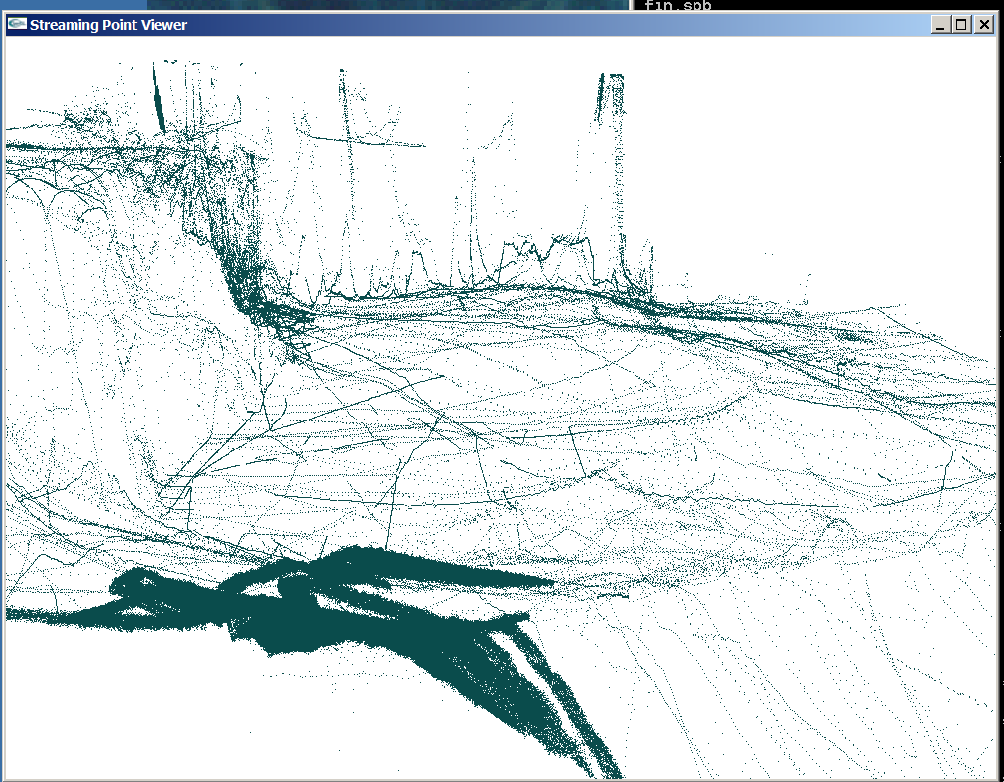
Better case: combining data sets at multiple resolutions and accuracies
Bathymetric data, Rob Anderson (NGA): sonar returns from a variety of sensors having different densities and error characteristics: roughly 90% from one very accurate and dense sensor (not pictured, but it would occupy the front 1/3 of the following image), 9% from one multisensory boom giving data along an overlapping path (seen dark) with seemingly stochastic position errors, 0.5% from a ship that tracked all over, and the remaining 0.5% from nearly 30 sensors, some giving isolated tracks, and some having obvious mis-registration errors.
The bathymetric data is so unevenly sampled that it is difficult to compare with an image-based compression scheme like JPEG2000. The bathymetric data in our single UTM zone 18R would require a 130,00x120,000 grid to get the 10cm post spacing of the most accurate sensor, or 31GB for 16 bit raw data. JPEG2000 would compress this by a factor of less than 200; we’ll be optimistic and say the data is 31MB, compressed. Storing the raw points in 55x4 format takes 150MB.
Storing a triangulation in binary format takes 330MB, but in compressed format takes 9.84MB, which is already better than JPEG by a factor of at least 3. Filtering and simplifying to 10% gives us 1.34MB, or 4.3% of the JPEG size, and to 1% gives 160KB, or 0.52% of the JPEG size.

Comparison of Encoding Philosophies
Consider the philosophies of encoding a raster vs. scattered data and an image vs. terrain.
The raster, by dividing the domain into equal-sized pixels, makes the resolution of data spatially uniform. This implicitly assumes that the spatial phenomena of interest, and the level of interest in these phenomena, is also roughly uniform. That is, you are no more interested in the road up a mountain, than in the impassible terrain that surrounds it. And in many cases this is true; when you are interested in the road, you pull out a different map with a representation of the roads, and don’t use your terrain map alone when driving. (In fact, one usually does not worry about harmonizing the views from both maps, as long as one can partition the tasks: first, drive to the trailhead, then start hiking.)
In computational analysis of digital terrain models, however, we often want to combine data from different spatial scales to make simplified models that suppress extraneous details (to keep the model manageable) but retain the essential features. Especially for applications in which linear features are key (roads in mobility, ridge lines in visibility, and valley lines in drainage) more drastic simplification can be performed away from the feature of interest.
In an image, discontinuities in color or intensity are relatively common; in terrain, discontinuities in elevation are rare, though discontinuities in slope are not too uncommon.
For digital surface models that include man-made structures, discontinuities are relatively common, so using an image encoding of a raster often makes sense. For digital terrain models, however, the sampling of data is much less uniform, suggesting that it makes sense to consider an irregular representation, and discontinuities of the underlying terrain are much less common, suggesting a smooth basis. Since slope discontinuities can be critical features in applications (curbs for drainage), they should be able to be represented accurately.
Contributions from centroid triangulation B-splines and interpolatory subdivision surfaces
The two approaches to “meshless wavelets” that we have explored, namely Liu’s centroid triangulations to generalize B-splines and Chui’s interpolatory subdivision surfaces, both have had roles to play in developing our compressed representation. We have used both subdivision and splines in looking at patches for the canyon data.
Furthermore, Liu’s scheme demonstrated to us the importance of being able to fit slope discontinuities. Chui’s scheme provides a interpolatory patch that we can now efficiently fit to data. We have it implemented in our streaming pipeline, and are experimenting with the parameters for best fitting to surfaces. The recent advance in speed of computing best fit subdivision surfaces (from 330 seconds to 7 seconds in MATLAB, as reported 28 Feb 08) was very encouraging.

