Using the HRTI Analysis Tool at UNC
Shawn Brown Jack Snoeyink
srbrown@cs.unc.edu snoeyink@cs.unc.edu

The HRTI Analysis Tool (HAT), version 2.0, was distributed to the terrain representation projects in GEO*, the NGA/Darpa collaboration program. At UNC-CH, we have begun using HAT for analyzing the terrain representations that we compute. Although HAT is a great tool with many powerful features, we have run into some problems getting it to work for our needs. Since, in the last meeting, we learned from NN that HAT is still in active development, we would like to suggest some features that would facilitate our use, and probably that of others. In particular, easy modifications would improve .BIL and .ASC support, improve the display of error metrics & histograms, and would better document what computations are performed. More extensive modifications would support irregular representation, such as TINs or splines.

Note: We are commenting on HRTI version 2.0 (including the documentation manual).

Raster DEM Import Capabilities:
The 2.0 version of the HRTI tool supports several formats (DTED, GeoTIFF, Smart Image, USGS Binary DEM, Star3i BIL, and ASCII Grid), but not all of these formats are standard or well documented.

For us, GeoTIFF appears to work just fine and as a work-around for UNC-CH, we can convert our results into this format to import our results into HRTI. We did not experiment with DTED, USGS Binary DEM, and are unfamiliar with Smart Image, so we won’t comment on those formats.

We are able to use ASCII Grid if we omit all header data, and import the resulting data as raw heights, but this is unsatisfactory – we’d rather be able to include the headers. We have been unable to find a description of Star3i BIL format, whose metadata files are not compatible with the files we currently have. Thus, we would like to see if the following formats can be added to the HRTI Analysis Tool:

Adding ESRI ArcInfo ASCII Grid (.ASC) Support:
Can the ASCII Grid format be modified to also support the ESRI ArcInfo ASCII Grid format? The HRTI-supported ASCII Grid format (.GRD) supports a height data set as 2 separate files: a metadata file contains the lat/long coordinates for the 4 corners of the data. The raw height data file consists of ASCII representations of floats in row major order, with rows separated by newlines.
This is similar to the ESRI ArcInfo ASCII Grid format (.ASC), with two main differences: In ArcInfo Grid, the header is included with the raw height data, and this header supports different metadata fields. See the example below, or documentation at this web site: http://geotools.codehaus.org/ArcInfo+ASCII+Grid+format.
.ASC File Format:
<Header>
<Raw Height Data>

Example ASCII File Data (.ASC):
ncols 157
nrows 171
xllcorner -156.08749650000
yllcorner 18.870890200000
cellsize 0.00833300
NODATA_value -9999
0 0 1 1 1 2 3 3 5 6 8 9 12 14 18 21 25 30 35 41 47 53
59 66 73 79 86 92 97 102 106 109 112 113 113 113 111 109 106
103 98 94 89 83 78 72 67 61 56 51 46 41 37 32 29 25 22 19
...

Note: Starting on the 7th line is raw height data, which is already equivalent to the current ASCII Grid format supported by the HRTI tool.

Note: One important consideration for the ESRI Grid format is support for the “NODATA_value” field, which we will discuss more below. In brief, any height data value matching this “NODATA_value” should not be displayed or processed for computing statistics/errors.

Adding standard .BIL Support:
Our code can easily create large BIL files for terrain, so we had hoped to use that to support HRTI analysis of our data. We are unable to find documentation for the metadata for the Star3i BIL format; it seems that Star3i was an Australian company that is now defunct? Our attempts to reverse engineer the current metadata header were not successful.

Here is a link to one description of the format that our code emits.
http://www.softwright.com/faq/support/toposcript_bil_file_format.html

We would like to ask that your current Star3i .BIL support be improved to also allow importing of data in the .BIL format described in the above hyperlink.

The raw height data is stored in binary format, 16 bit integer (2 bytes), 32 bit integer (4 bytes), or 32 bit float (4 bytes), stored in the usual rows of columns format. The raw bytes can be stored either using Little Endian or Big Endian notation. A field in the header specifies which byte ordering scheme to use when interpreting the raw data. The binary raw height data file usually has a .bil extension. In addition to the raw height data there is an ASCII header file, with the extension .hdr, for specifying the metadata describing the terrain. Optionally, there is another metadata file called the World file, usually with the extension .blw, which specifies coordinates.

Here is an Example BIL Header file (.HDR)

Example Header File Data:
nrows 1380 // # of Rows in height field
ncols 1825 // # of Columns in height field
nbands 1 // # of Bands (for banded files)
nbits 16 // Bits per entry
layout bil
nodata -9999 // No Data Value
byteorder I // Little Endian (I) /Big Endian
ulxmap 429759.00 // UTM coordinate
ulymap 4514131.00 // UTM coordinate
xdim 1.00 // Cellsize (horizontal)
ydim 1.00 // Cellsize (vertical)

Here is an Example Optional BIL World File (.BLW)

Example World File Data
1 // Cellsize (horizontal)
0.0
0.0
-1 // Cellsize (vertical)
429759 // UTM coordinate (left)
4514131 // UTM coordinate (top)

Statistics and Reporting
Some issues with statistics are simply documentation of what is computed and reported. Others involve discarding outliers to show the typical behavior, especially for handling NO_DATA values.

Outputting Error Metrics:
When comparing two DEM’s (Comparison & Ground Truth), the main window outputs a number of error statistics. The min and max error column are, I think, clear, but I would also like to know the values of other error measures, including of Average Error, Absolute Average Error, and Root Mean Square (RMS) of error, for both height and slope differences.
This information may already be output; we just don’t know how to interpret it. If this is indeed the case, then we just need better documentation explaining how to interpret the error metric results.

For example, here are some error metrics we calculate when comparing a decompressed DEM against the original uncompressed DEM in our own internal error comparison tool.

Min X | -912
Max X | 912
Avg X | -0.279
Min Y | -689.5
Max Y | 689.5
Avg Y | -0.0205
Min Z | 1440.51
Max Z | 1957.26
Avg Z | 1616.55
Min(elev err) | -1.313
Max(elev err) | 1.107
Avg(elev err) | 0.001
Abs(Avg(elev err)) | 0.098
RMS(elev err) | 0.137
Min(slope err) | 0
Max(slope err) | 145.078
Avg(slope err) | 4.419
Abs(Avg(slope err)) | 4.419
RMS(slope err) | 5.671

Here <X,Y,Z> refer to 3D position, “elev err” refers to differences in elevation between two surfaces, and “slope err” refers to angular deviation (in degrees) between corresponding slope normals to the two surfaces.

More Information on Techniques:
The documentation currently has a great appendix describing the algorithms used in computing slopes. It would be useful to have additional appendices on the statistical techniques used to compute error metrics, on what is meant by the “Err. Norm” button (which sounds useful, but this appears to only be functional if you are using THED), and on the 3 horizontal registration algorithms.

NO DATA value handling:
Although some ASCII Grid and .BIL formats include a NO_DATA value specification in the header or meta-data file, the HRTI-supported format does not appear to support this, but treats the NO_DATA value (often -9999) as a valid elevation. This corrupts the elevation color selection, the error statistics, and the error histograms.
Because our techniques focus on interpolation from irregular data sets, we tend to generate NO_DATA values to fill out to the boundary of the bounding box, and thus have great problems when these values are taken as elevations.

- Elevation Color Selection: The HRTI Analysis Tool uses the entire data range to determine the mapping from elevation to colors. Using the NO_DATA value throws off the valid range of display values, When, for example, our university of Utah data set is seen to range from -9999 to 1958, instead of the true range from 1000 to 1958, the terrain details are effectively hidden because the true range is mapped into less than 10% of the color range. Fortunately, we can work around this problem by manually adjusting the color ranges.

- Biased Error Statistics: Including the NO_DATA values into the error calculations for elevation and slope throws off the resulting statistics. Since most of our NO_DATA values are around the boundary, we can minimize the impact by specifying a smaller bounding box to exclude the boundary. It would be good to be able to make this specification in a file, instead of graphically.

- Biased Histograms: The large errors from treating NO_DATA as valid elevation become outliers that determine the histograms, as described in the next section. In our context, selecting a bounding box to exclude the area near the boundary again helps minimize the impact, but being able to set the range is also needed.
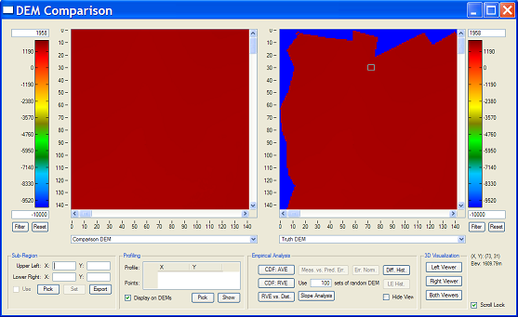

Fig 1: Shows how a small corner of the University of Utah data set shows elevation color ranges determined by outliers from NODATA values, which are assigned by our irregular representation around the boundary.

The desired behavior is to be able to specify a NO_DATA value and then have all underlying calculations simply ignore rasters that contain this value (either in the Comparison DEM or Truth DEM or both). As mentioned above, ESRI ArcInfo ASCII Grid and .BIL formats allow NO_DATA to be specified in the header, so these should be handled correctly in the user display and during generation of error metrics.
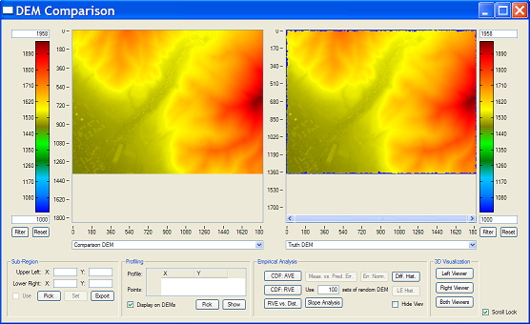
Fig 2: University of Utah data set showing a more informative elevation to color mapping, created manually after loading the elevation file.
Note the small but noticeable ragged edge (in blue) of the decompressed TIN file

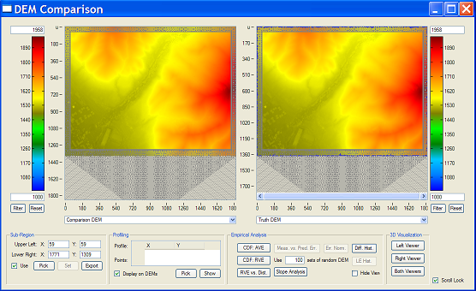
Fig 3: Using a bounding box to avoid NO DATA regions (ragged edges), which would otherwise produce invalid error metrics and histograms.

Histogram range adjustment:

The error histograms have their range determined by outliers in the data, which means that the typical error values all land in a small number of bins. This is especially problematic for files with a NO_DATA value (such as -9999) that winds up being an extreme outlier, but even if we set a bounding box that includes only valid data, we still have problems. For example, our University of Utah data the max height differences may vary from -29 to +54 meters but the vast majority of height differences actually fall in the smaller range of -4 to +4 meters.
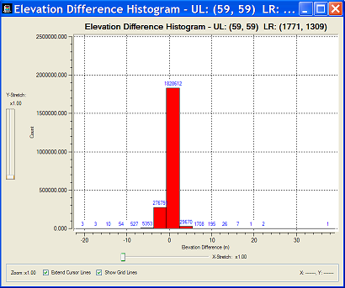
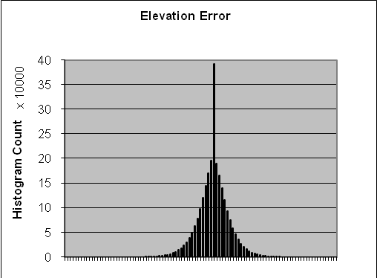

Fig 4: `Height Differences’ histogram for University of Utah data in the HRTI Analysis tool (left) and a manually computed Excel histogram (right)
HRTI uses only 20 bins, with the vast majority falling into a single bin; using 100 bins better shows the shape of the distribution.

We would like to request that the histogram tool be modified to allow the following:
- Allow the user to choose the number of histogram bins (default to, say, 30).
- Allow the user to specify a min,max range that defaults to the data range, but can be set smaller. (This is similar to the current filtering for the height color bar on the DEM comparison dialog.)

Processing irregular representations in HRTI:
At UNC-CH, we are working with irregular representations of terrain as TINs and splines. Some of our source data is raster DEM, but much of it is raw LIDAR or sonar that we work with as irregular samples. Our specialty is handling, compressing, and decompressing large irregular data sets, such as could come from raw LIDAR, sonar, or conflation of these with other base data. Thus, we would like NGA to have the capability to test irregular data sets and irregular representations built upon them.

Adding TINs to HRTI:
The simplest form of irregular representation would be a TIN triangulated surface represented in some common graphics format. We have our own set of TIN formats that allows streaming with very low memory. These are very similar to .OBJ format, so we could easily add support for any of these common graphics formats:

WaveFront Polygon Format (.OBJ)
http://en.wikipedia.org/wiki/Obj

Stanford Polygon Format (.PLY)
http://en.wikipedia.org/wiki/PLY_(file_format)

GeomView Polygon Format (.OFF) http://www.geomview.org/docs/html/OFF.html

See Figure 1 for an example of what can happen (Ragged Edges) when trying to compare TIN data vs. DEM data for analysis.

Adding point cloud ground truth to HRTI:
We had developed one of our own tools to compare a ground truth point cloud against a terrain interpolation module, which allowed us to test raster and irregular models on both regular and irregular sample sets. (We also explored using different perceptual features to be able to show two or more error results, whether from different representation/interpolation schemes (raster, piecewise-linear TIN, and spline) or from different terrain parameters (elevation, slope, and aspect). See http://www.csc.ncsu.edu/faculty/healey/download/3dpvt_poster.06.pdf for some details.)

To add this to HRTI, one would need to also add support for testing point cloud samples.

