GISRUK 2005

Session 3D - Data Qualitv

LiDAR for DSMs:

An Exploration of Data Issues and Errors

Charlotte Leigh, Rob Oliver, David Kidner & Malcolm Thomas

GIS Research Centre, University of Glamorgan, Pontypridd, Rhondda Cynon Taff, WALES CF371DL e-mail: cleigh@glam.ac.uk

KEYWORDS: LIDAR, elevation modelling, error assessment
1. Introduction
Light detection and ranging (LiDAR) or laserscanning is a proven technology which has been used since the early 1970s in diverse domains including atmospheric modelling, catching speeding motorists and extra-terrestrial applications (Kreslavsky and Head, 1999). More recently, as a result of improved accuracies in GPS and INS (described further in section 2) LiDAR is quickly becoming the preferred acquisition choice for elevation data. This is as a result of its dense sampling, quality, and level of detail far exceeding traditional methods for surveying large areas.
Digital elevation models (DEMs), which model the earth's surface, are essential for numerous applications, for example orthophoto creation, highway and earthworks design and military applications (Burrough and McDonell, 1998). The need for accurate DEMs is of crucial importance as errors in derived products will propagate and impact upon spatial analyses (Hunter and Goodchild, 1997). LiDAR has evolved into a technique for the efficient capture of high resolution digital surface models (DSMs), suitable for large-scale analyses, such as assessing flood risk, coastal monitoring, including the assessment of storm damage to beaches, geomorphology, landfill monitoring and assessment, powerline planning and management, and engineering applications. One of its main advantages is the ability to map topography in remote, difficult to access, or environmentally sensitive areas such as salt marshes, forests and woodland, cliff coastlines and dune systems. Meanwhile, some researchers (for example, Channel Coastal Observatory, 2004) have dismissed LiDAR as a viable technique for the time being, in preference to the more traditional surveying methods such as photogrammetry.
To provide a detailed and accurate summary of LiDAR issues and errors, seven years of
LiDAR datasets (from 1998 to 2004) have been closely examined for a large area of South Wales. In addition, the LiDAR data has been validated and compared with an accurate manual kinematic GPS ground survey. This paper focuses specifically on the identified sources of LiDAR data artefacts and errors that may affect the accuracy of the end products (DSMs). The errors and issues that are addressed include, instrument/systematic errors, point pattern problems, LiDAR system artefacts, gross errors and data blunders, coordinate transformation and conversion errors, post-processing filtering and classification problems. Such issues have to be addressed in order to increase confidence in this technology .

110

GISRUK 2005

Session 3D - Data qualitv

2. LiDAR
There are three basic generic types of LiDAR: Range Finder, DIAL and Doppler. This paper will only deal with Range Finder LiDAR systems that are used to provide geographic elevation data of the Earth's surface. However, often additional data aquistion tools are incorporated with the Range Finder, such as a digital camera, video recording devices, and/or a thermal imager.
A LiDAR system comprises three data collection tools mounted on an aircraft: a laser scanner, a Global positioning System (GPS) receiver and an Inertial Navigation System (INS). The GPS accurately measures the position of the aircraft and the INS measures the roll, pitch and yaw of the aircraft (Figure 1). The laser is fired to the Earth's surface by means of an oscillating mirror, which results in a zig zag sampling pattern. The elapsed time from when the laser is emitted from the sensor to intercepting an object or the ground is measured, and knowing the speed of light, the distance can be easily calculated.

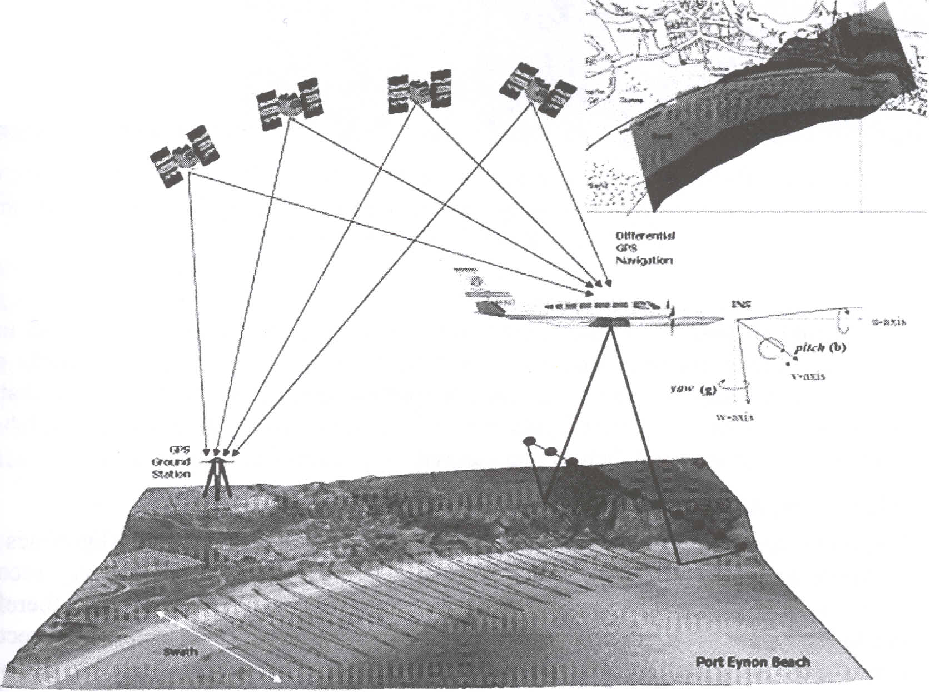
Figure 1. A typical LiDAR System that produces a swath offmely sampled x,y,z surface points for DSM generation (top right). Study area is Port Eynon beach in the Gower, S. Wales.
The LiDAR data can be post-processed into a number of different output formats or digital surface models, including a first-pulse return DSM; a last-pulse return DSM (which has the effect of removing some of the vegetation as the laser footprint will penetrate gaps in the foliage); a return strength intensity image - useful for classifying surface features; and a bare-Earth DEM in which all the vegetation and surface features have been filtered out (see Figure 2).
111
GISRUK 2005

Session 3B - _Data Qualitv

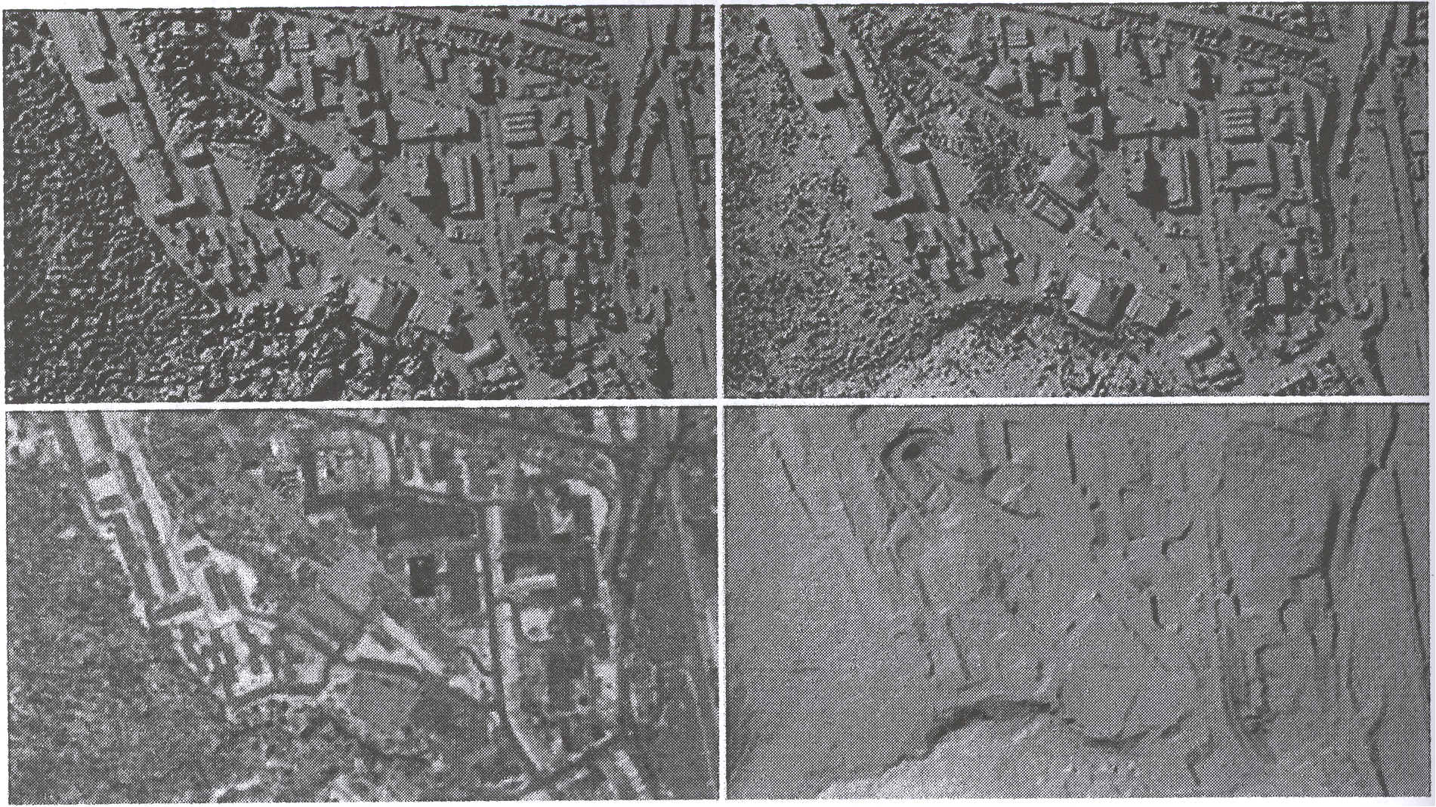
Figure 2. Derived LiDAR DSM Products: A First Pulse Return DSM, A Last Pulse Return DSM, An Intensity (Signal Strength) Image, and a Bare Earth (Filtered) DEM. Study area is the University of Glamorgan campus.

The nature of LiDAR data is complex, large and unwieldly. In order to allow the data to be usable its complexity requires an understanding of how the data is acquired, post processed, structured and analysed. The most important concept is the realisation that all data types are subject to error, particularly remotely sensed data such as LiDAR, which are subject to a number of external factors that can reduce accuracy and confidence.
3. LiDAR Errors, Artefacts and Issues
LiDAR surveys are often complex, consisting of dozens of overlapping flightlines (or swaths), where as many as 10,000 to 30,000 data points can be captured every second. Errors and artefacts in the data are quite normal and are to be expected. It is therefore important to have data handling and management strategies in place to identify, correct, or remove any spurious data. In order to develop these strategies, it is essential to have a detailed understanding of the types of errors or artefacts that can be expected, and their likely impact on the derived DSM products.
To achieve this understanding of LiDAR, a detailed case study is being undertaken for an area of the Gower in South Wales. To date, data have been collected at yearly intervals since 1998 (i.e. seven surveys to 2004), primarily for a coastal monitoring programme (Kidner et aI., 2004). A typical survey will comprise 25 to 30 million data points, over a geographic extent of 20x12 kIns, with about 50 flight survey lines (Fig. 3). The overlapping flight lines may be sampled at different time frames (i.e. not consecutively), from 30 minutes to a few days apart, with different GPS satellite configurations, in different weather conditions, and in different orientations. It is therefore natural to

112
GISRUK 2005
Session 3B - Data Qualitv

question the effect that the survey characteristics will have on the quality of the final products.
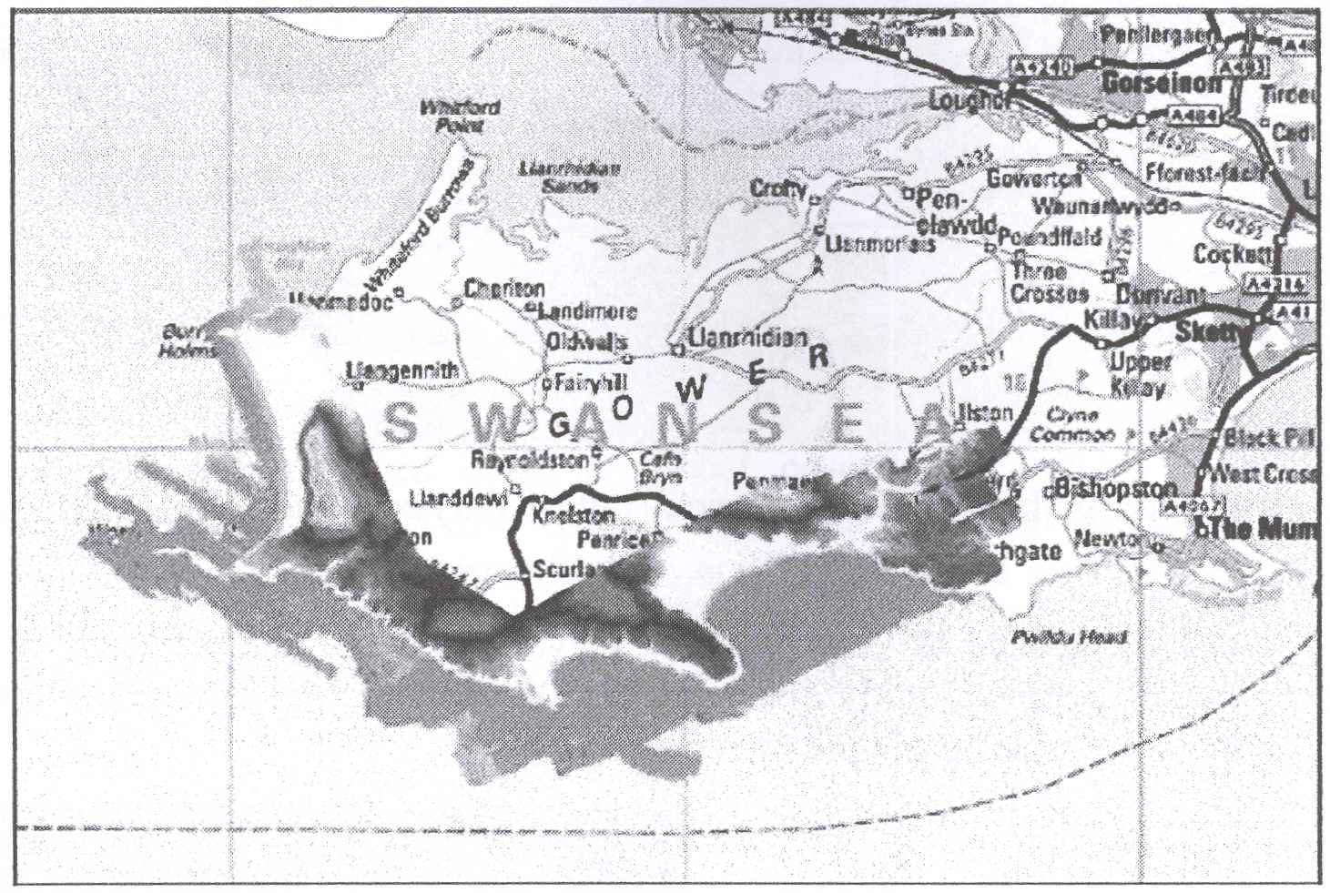
Figure 3. LiDAR Survey Data for Gower (2003). A typical survey is composed of data
from up to 50 flight lines, consisting of 25 to 30 million data points.
Errors in airborne surveys can manifest in many different ways (e.g. Figure 4). As with traditional aerial photographic surveys it is always advisable to have good ground control points to check the validity of the LiDAR data collected. In these case studies, for each LiDAR survey, a kinematic GPS ground survey is undertaken on the same day. In this way, the magnitude of the LiDAR errors and their type (e.g. systematic or random) can be quantified and qualified. In addition, this can allow for some remedial post-processing to certain types of errors, e.g. systematic offset errors.
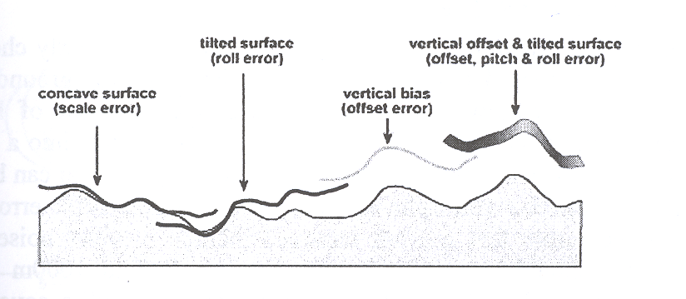
Figure 4. Errors that may be exhibited from airborne sensing platforms.
The following sections attempt to identify the LiDAR data issues that have been perceived
as problematical and worthy of closer investigation.
3.1 Large Blunders
Large blunders are very unreasonable elevation values, which can be attributed to a variety I of factors, including bird strikes and instrument errors. These are generally very few and
113
GISRUK 2005

Session 3B= Data Qualitv

far between, but do occasionally occur. Nevertheless, these points should be identified and removed before the data is interpolated to a DSM (Fig. 5).

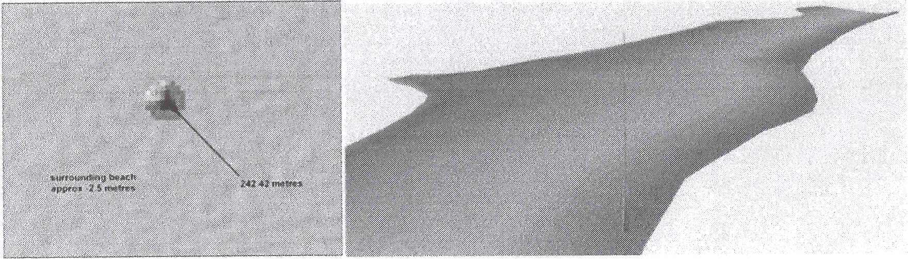
Figure 5. Large blunder (one spurious data point) corrupting the DSM.
3.2 Small Blunders
Small blunders can be defined as very localised elevation errors, due primarily to surface objects such as cars or people slightly distorting the DSM. This is illustrated below in Fig. 6 in the case of the laser striking people on a beach.

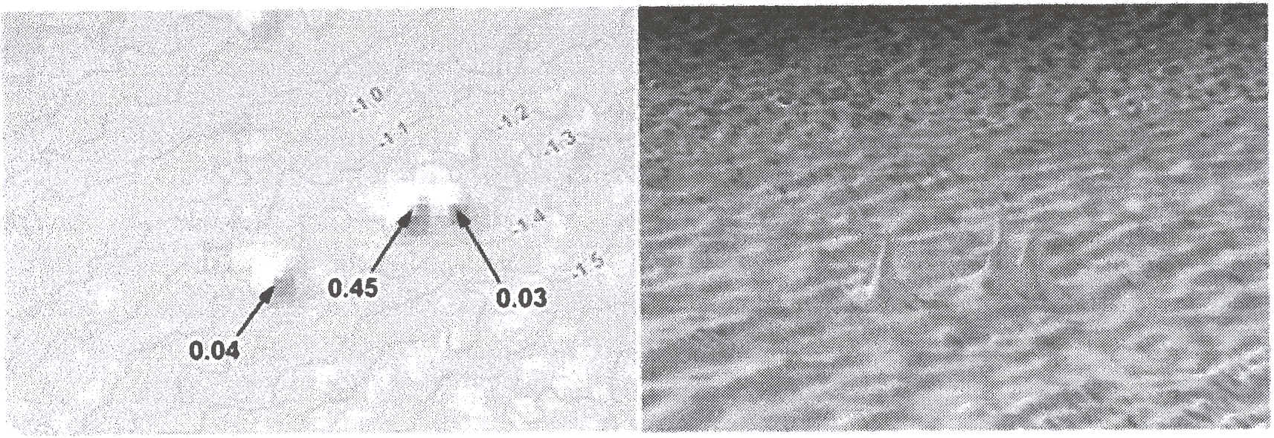
Figure 6. Small blunders (people!) represented as local spikes in the DSM.
3.3 Positional (GPS and INS) Errors
The INS, GPS, and LiDAR unit are all fmely calibrated and regularly checked, such that the accuracy of the surveyed data can be validated with very little ground truth or survey points. However, it is acknowledged that the largest component of LiDAR error is probably due to positional error and the transformation of the data into a local coordinate system from WGS 84. The major factors degrading GPS signals that can be removed with differential methods are the atmosphere, ionosphere, satellite orbit errors, and satellite clock errors. Some errors that are not removed include receiver noise and multipath. However, multipath should be minimal for a receiver 700 to 1000m off the ground. LiDAR missions are usually planned to ensure maximum satellite coverage, while this coverage data is continually logged to estimate the standard deviation (and hence confidence) of the GPS measurements at any moment in the LiDAR survey (Fig 7).

114

GISRUK 2005

Session 3D - Data Qualitv

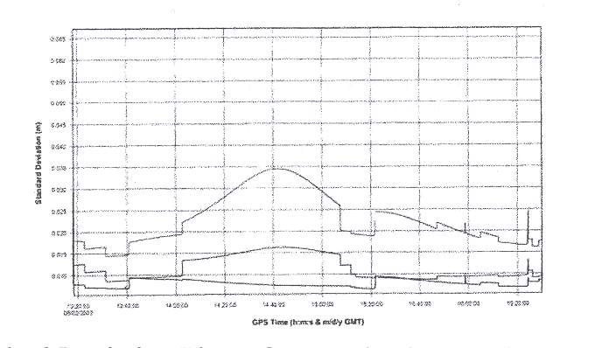
Figure 7. GPS Standard Deviation Plots of x,y, and z through time of the LiDAR survey. 3.4 Coordinate Transformation Errors
GPS coordinates are recorded using a global co-ordinate system called the WorId Geographic System of 1984 (WGS84), which includes a vertical datum. The intital postprocessing therefore includes the transformation of the data to a local reference system and vertical datum (petzold, Reiss et al. 1999; Daniels 2001). The conversion process can induce systematic errors into the data. However, the accuracy with which conversions can now be made into OSGB National Grid are far superior due to better transform models post-2002.
3.5 Non-Sequential Flightlines
Depending on the area to be flown and other constraints, the data may be collected on different days; while at the end of the flightline the aircraft turns very gently (in order not to lose lock on the GPS receivers), so swaths are not necessarily captured sequentially (Fig. 8). This results in different GPS configurations for overlapping areas, possibly with different accuracies.

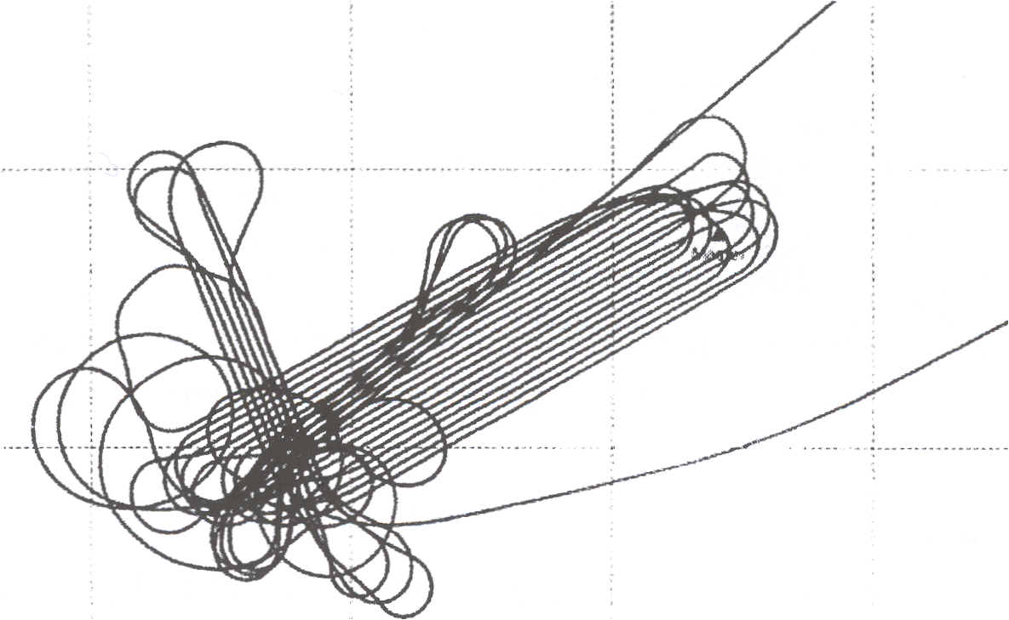
5km

Figure 8. Day 1 Flightline LiDAR Capture Log for the Gower in August 2003. Swaths are not necessarily sequential, while some areas are captured by multiple passes in different directions.

115

GISRUK 2005

Session 3D - Data Qualitv

3.6 Multiple Swath Overlaps
Following on from 3.5, areas covered by multiple swaths (e.g. see Fig. 8) may produce inconsistent elevation returns, probably due to systematic error in a specific flightline (Fig. 9). In effect, each flightline dataset needs to be processed and quality checked independently of other swaths.

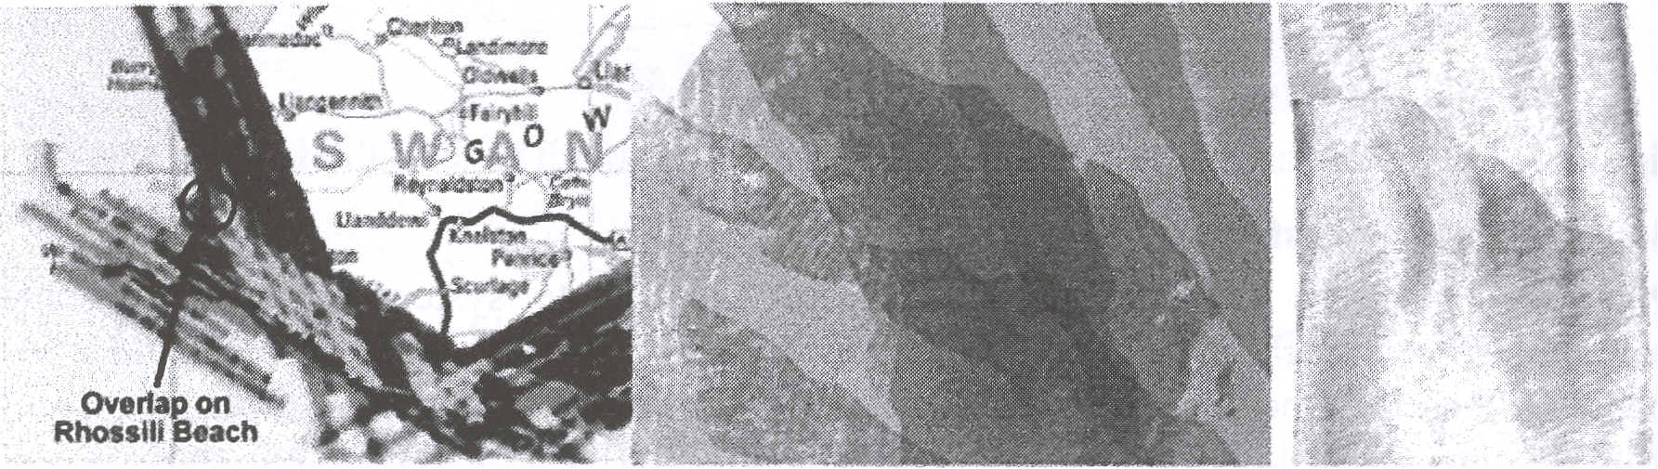
Figure 9. Swath Overlap Issues (i) Colour-Coded Point Densities (ii) Individual LiDAR Point Samples (iii) Elevation Differences.

3.7 Laser Sampling Pattern
Scanning is undertaken in a zigzag fashion (Figure 1 0 below). The laser remains fixed in the aircraft, but a scanning mirror is used to reflect the light onto the surface below. However, this means that there are areas of the surface that are not scanned or surveyed between scanning lines. The circles in Fig. 10 represent "dead zones" on the ground where no samples are taken.

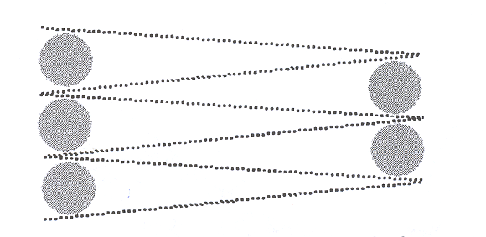
Figure 10. The ZigZag Pattern of Laser Scanning. Each dot represents an x,y,z return point, while circles represent relatively large "dead areas" where no samples are taken.

3.8 Swath Edge Effects
As the scanning mirror changes direction at the end of the swath, it will slow down, stop, and then swing backwards. This has the effect of creating many additional data points at the end of the swath (Fig. 11). The effect of these data on the DSM was felt worthy of further investigation.

116

GISRUK 2005

Session 3B - Data Qualitv

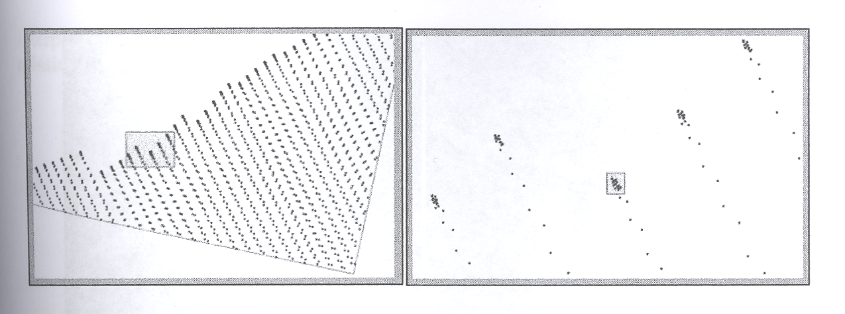
Figure 11. Swath Edge Effects: Dense sampling of points at the end (edge) of a swath, where th_ oscillating mirror changes scanning direction.

3.9 Banding in the Point Distribution
Related to the issues of multiple swath overlaps and swath edge effects is the effect of
banding in the LiDAR point sampling (Fig. 12). This is where there is a sharp increase in density of points due primarily to a slowing down in the speed of the aircraft, probably due to turbulence or wind. Similarly, there may be a stretching (and under-sampling) due to an increase in speed of the aircraft.
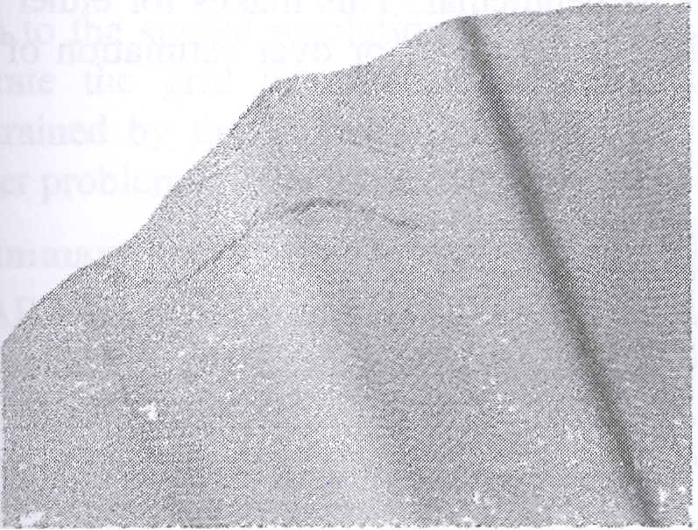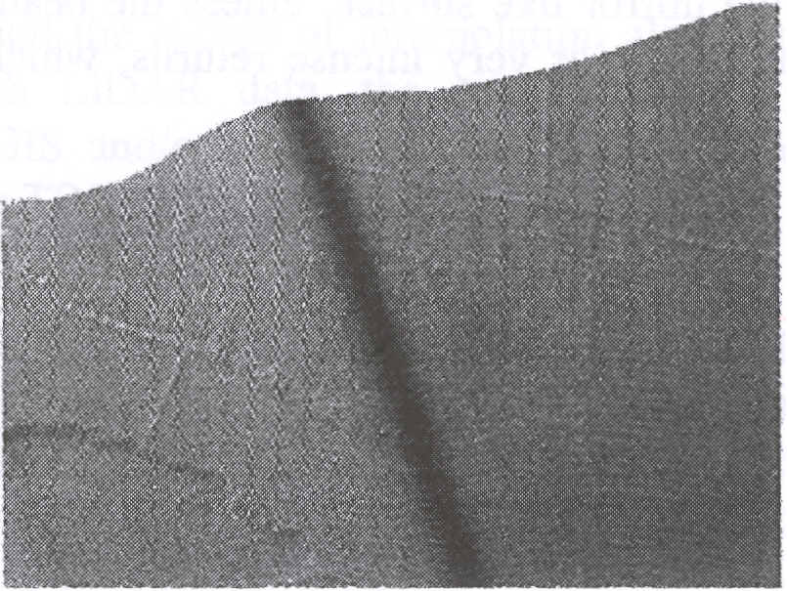
Figure 12. Banding in the LiDAR sampling (over-sampling) due to a change in speed of the aircraft.

3.10 Rippling or Striping of the DSM
Due to the zig-zag sampling pattern of the laser, the processed DSM may often exhibit ripples or stripes. This is generally caused by close neighbours in different sweeps of the laser scan. The problem is perhaps more of an aesthetic one, but is exaggerated if a TIN is adopted as the data model for the DSM (Fig. 13). Also, the problem tends to be exaggerated towards the ends of the swaths, as the separation distance between points becomes larger.

117

GISRUK 2005
Session 3D - Data Qualitv

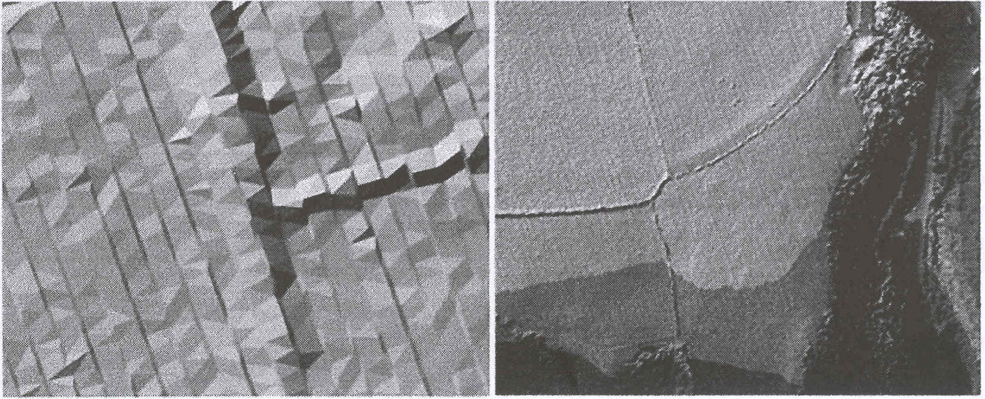
Figure 13. Rippling or Striping Effect in the DSM caused by the zig-zag sampling strategy of the laser.

3.11 Topographic Features
The interaction of the laser beam with ground features (for example, the feature type and its surface) has the potential to affect the returned signal and thus the recorded measurements. Using topographic LiDAR which uses red laser light, some features are very poor reflectors of the laser signal, i.e. water and newly laid bitumen roads. Water features are notoriously hard to gather data on as there is virtually no scattering of the light from the mirror like surface, unless the beam is perpendicular. This makes for either few return signals, or very intense returns, which lead to an under or over estimation of the water height.


Figure 14. Difference in sampling densities at the land/water interface.
3.12 Vertical Structures
A recognised problem with LiDAR are the differences in recorded elevation at the boundaries or edges of vertical structures, such as walls, buildings and cliffs. In the DSM, these structures often appear at shallower gradients, e.g. a vertical face might be represented by a face at 60 degrees. Vertical structures might be sampled by a LiDAR swath "climbing" up the face of the structure. This translates to points in the X - Y plane having different elevation values, hence the face often tends to get smoothed during
118
GISRUK 2005

Session 3D - Data Qualitv

interpolation. The problem is often exasperated by an overlapping flightline capturing (or missing) the structure at another angle (Fig. 15).
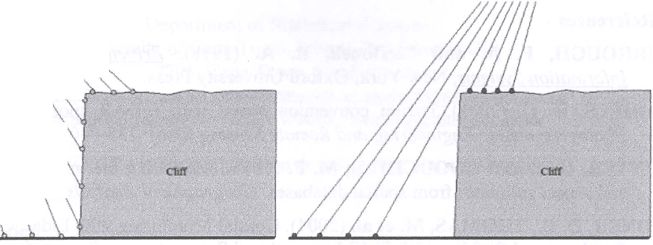
Figure 15. LiDAR sampling of vertical structures by overlapping flightlines. In the left image, points in the same XY plane exhibit different Z values, while in the right image, the
vertical nature of the feature may be missed.

3.13 Digital Surface Model Issues
The choice of data structure for the LiDAR DSM is also an issue with respect to the accuracy of LiDAR. If a regular grid lattice is used, then serious consideration should be given to the spatial resolution of the model, and the choice of interpolation algorithm to generate the grid samples. Too often with LiDAR data, the spatial resolution is constrained by the limitations of the user's GIS and/or physical RAM. This is often a greater problem for the more memory-intensive TIN.
4. Summary and Future Work
LiDAR has come of age in the last few years and is fmnly establishing itself as a viable data collection platfonn, particularly for inaccessible environments. It fills a gap in the data collection portfolio, between the highly accurate, but expensive and time consuming techniques of photogrammetry and land survey at one end of the scale and the lower resolution and accuracy methods of Radar collection techniques such as IFSAR. LiDAR produces quite accurate, dense, and rapidly obtained data, and has several advantages over other techniques, being an active sensor system.
However, further research is needed to understand, quantifY and qualifY the possible errors in LiDAR data. A number of areas have been highlighted which can give some cause for concern with respect to the accuracy of LiDAR. Currently, the focus of this research is on evaluating each of these potential issues and their effect on the fmal DSM for accurate analysis (i.e. beach profiling and volume calculations). In order to do this, a number of detailed kinematic GPS surveys have been undertaken to analyse the possible errors and "fme tune" the DSM where systematic errors have been identified. This research would perhaps not have been possible without access to such a detailed seven-year repository of LiDAR data. Only by analysing the differences between data sets ITom year-to-yearcan we begin to understand the idiosyncrasies of LiDAR and begin to put in place strategies to handle and post-process the data better.
119

GISRUK 2005

Session 3B - Data Qualitv

In the full paper, each of the issues identified will be extended to consider their relative magnitude and importance, together with a suggested strategy to mitigate its effect on the output DSM. The presentation will give an overview of this research and also focus on the end application of how this data is being used for accurate beach modelling.
5. References
BURROUGH, P. A. and McDonell, R. A. (1998). Principles of Geographical Information SYstems. New York, Oxford University Press.
DANIELS, R. C. (2001). Datum conversion issues with LiDAR spot elevation data. Photogrammetric Engineering and Remote Sensing 67(6): 735-740.
HUNTER, G. J. and GOODCHILD, M. F. (1997). Modelling the uncertainty of slope and aspect estimates from spatial databases. Geographical Analysis 29: 35-49.
KIDNER, D. B., THOMAS, M. et al. (2004). Coastal Monitoring with Lidar: Challenges, Problems and Pitfalls. 11th SPIE International Symposium on Remote Sensing, Gran Canaria.
KRESLAVSKY, M. and HEAD, J. (1999). Kilometer-scale slopes on Mars and their correlation with geologic units: Initial results from Mars Orbiter Laser Altimeter (MOLA) data. Journal of Geophvsical Research 104: 21911-21924.
PETZOLD, B., REISS, P. et al. (1999). Laser Scanning - surveying and mapping agencies are using a new technique for the derivation of digital terrain models. ISPRS Journal of Photogrammetry and Remote Sensing 54: 95-104.

6. Acknowledgements
The authors would like to thank the generous support and help of the National Assembly for Wales (NA W), including Chris Morgan, Carolyn Warburton, Sue Martin and Andrew Adcock. In addition, we would like to thank Nick Holden of the Environment Agency for some very useful help, advice and support. The datasets described in this research were provided by the Environment Agency, Infoterra, and the NA W.
Biography
The principal author (Charlotte Leigh) has just finished her first year of study at PhD level (Remote Sensing for Coastal Monitoring). The focus of the PhD is on investigating a variety of difftrent remotely sensed datasets (LiDAR, bathymetry, GPS, photogrammetry, etc.) for monitoring the effect that offshore dredging may have on the coastal environment. Charlotte recently graduated with a First Class Honours degree in Geography and GIS from the University of Glamorgan.

120

